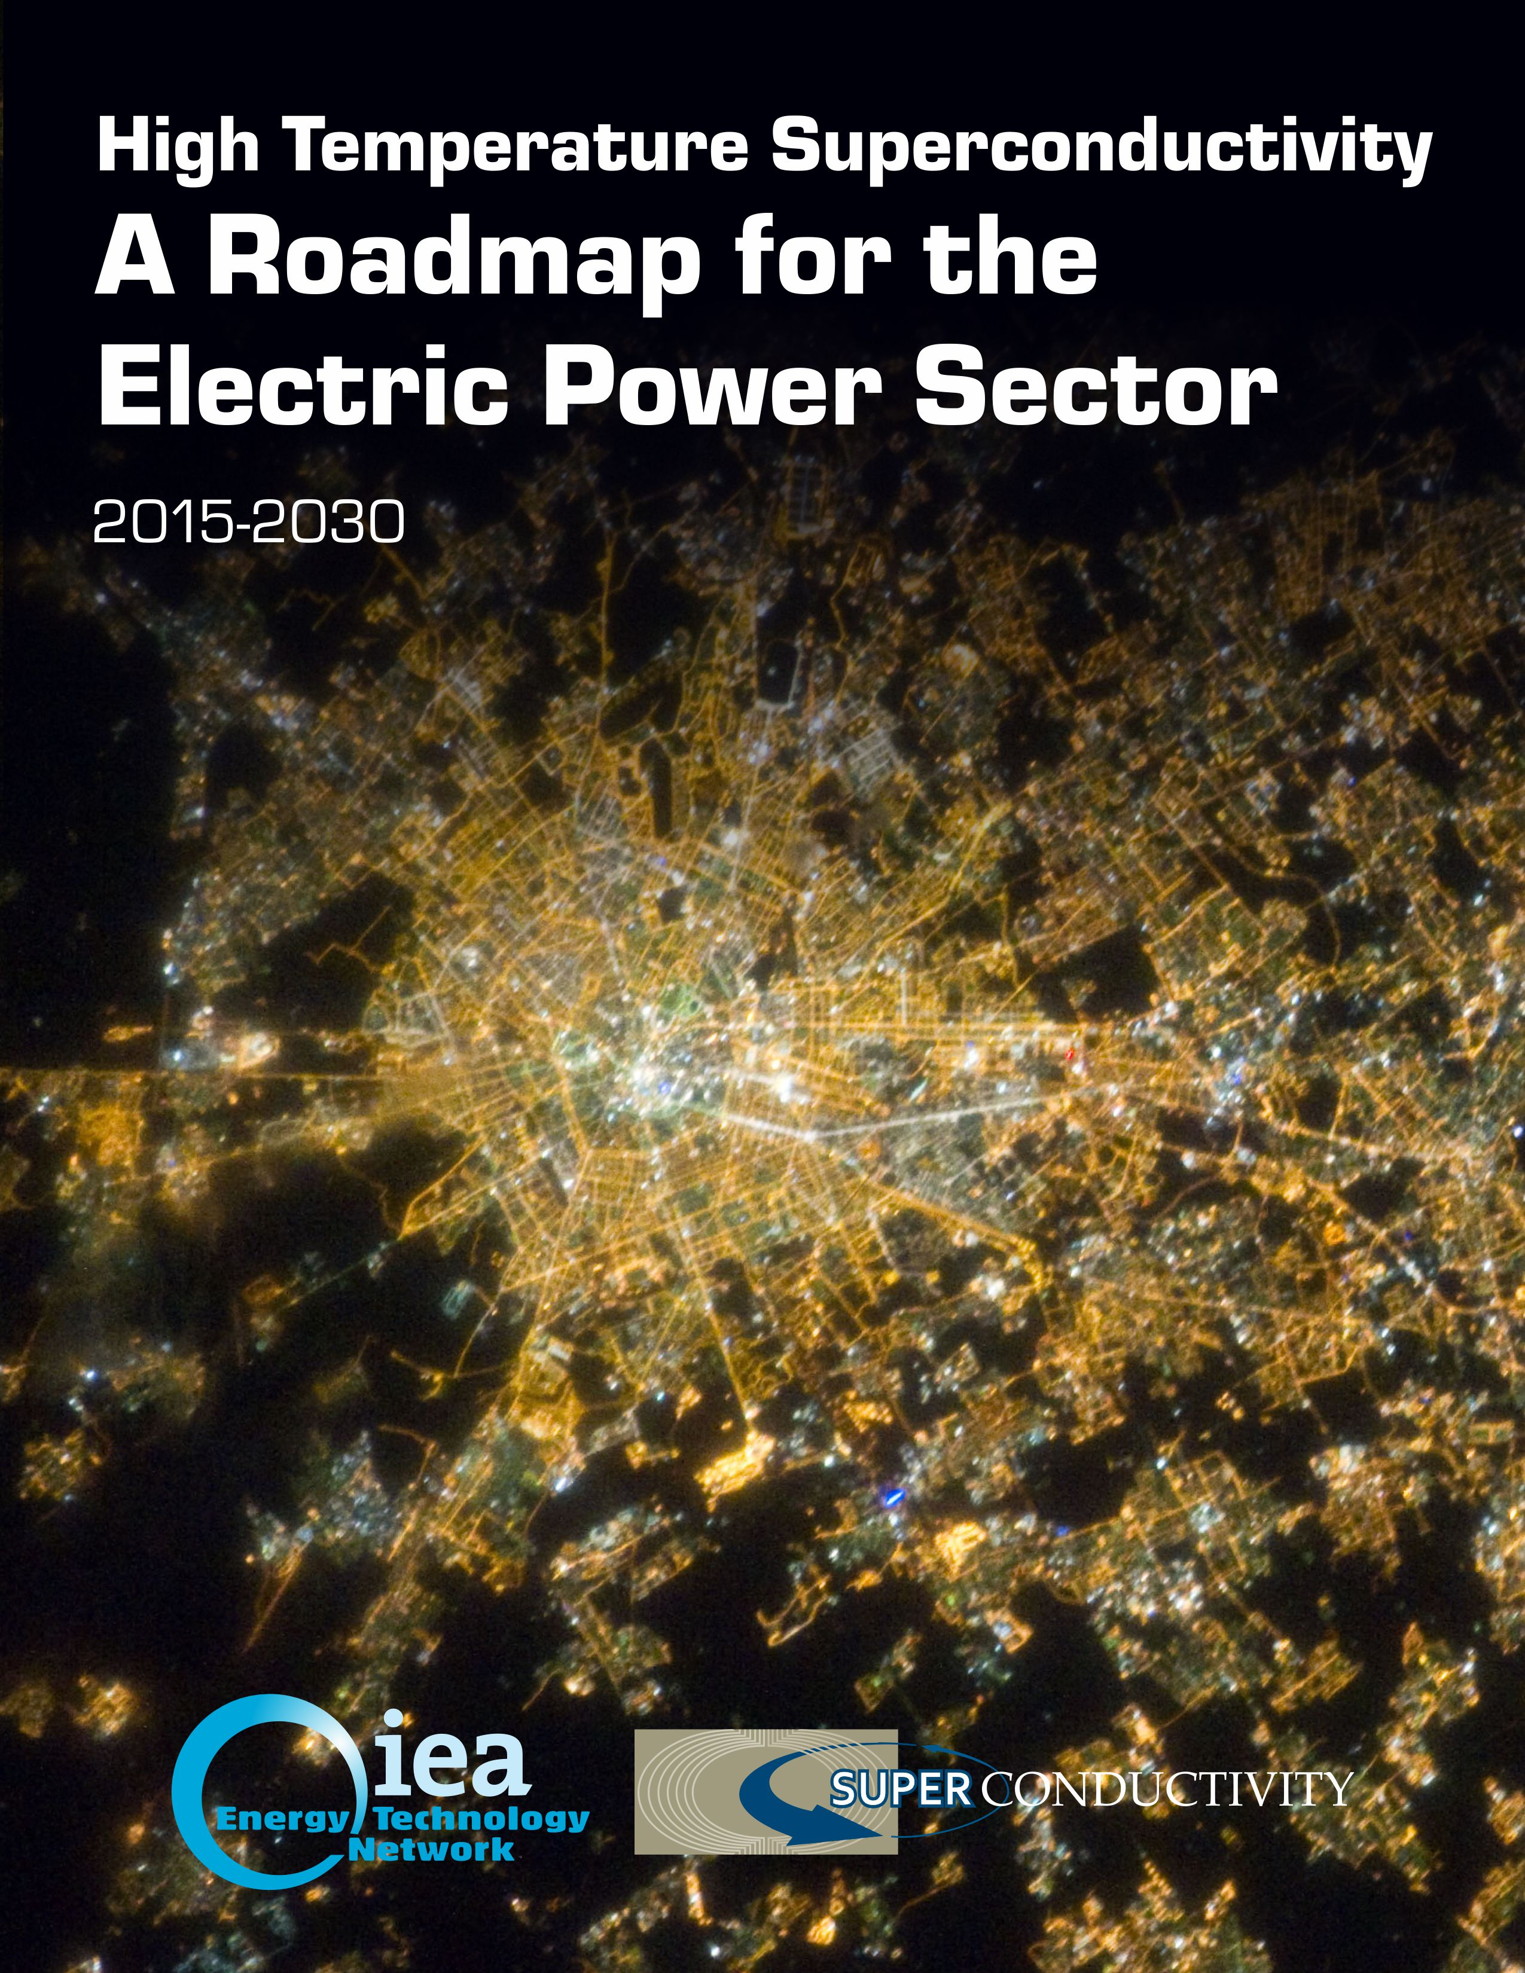

This work was done for and sponsored by the signatories of the International Energy Agency (IEA)

Implementing Agreement for a Cooperative Programme for Assessing the Impacts of High Temperature Superconductivity for the Electric Power Sector

Authors of this Roadmap:

Yutaka Yamada, International Superconductivity Technology Center

Brian Marchionini, Energetics Incorporated

### *The Cover*

*The world’s cities have a high concentration of energy demands and complex electrical networks. This photo of the Milan, Italy region at night shows the interconnectedness of their electric grid. Superconductivity for the electric power sector can help with grid modernization efforts. RSE and A2A Reti Elettriche collaborated to design, develop, test, and install Italy’s first superconducting fault current limiter (12 kV/4.6 MVA). The device is located in Milan and provides single feeder protection for an in-grid distribution-voltage application.*

*Photo courtesy of the National Aeronautics and Space Administration in the United States.*

# International Energy Agency Mission

The IEA is an autonomous organization which works to ensure reliable, affordable and clean energy for its 29 member countries and beyond. The IEA has four main areas of focus: energy security, economic development, environmental awareness and engagement worldwide.

Founded in 1974, the IEA was initially designed to help countries co-ordinate a collective response to major disruptions in the supply of oil such as the crisis of 1973-1974. While this remains a key aspect of its work, the IEA has evolved and expanded. It is at the heart of global dialogue on energy, providing authoritative statistics and analysis.

As an autonomous organization, the IEA examines the full spectrum of energy issues and advocates policies that will enhance the reliability, affordability and sustainability of energy in its 29 members countries and beyond.

The four main areas of IEA focus are:

* **Energy security**: Promoting diversity, efficiency and flexibility within all energy sectors;
* **Economic development**: Ensuring the stable supply of energy to IEA member countries and promoting free markets to foster economic growth and eliminate energy poverty;
* **Environmental awareness**: Enhancing international knowledge of options for tackling climate change; and
* **Engagement worldwide**: Working closely with non-member countries, especially major producers and consumers, to find solutions to shared energy and environmental concerns.

# Foreword

The energy systems of most countries worldwide are undergoing a very rapid evolution. The reasons for these changes are found in several trends, and in particular to:

* The increasing consciousness of the importance of reducing greenhouse gas emissions and mitigating the effects of climate change
* The necessity of adopting all means of increasing energy efficiency and reducing energy consumption
* The geopolitical events affecting countries mutual relationships
* The progressive aging of the electricity infrastructures that need to be modernized by deploying new technologies to enable upgraded capabilities, advanced real time monitoring, better failure detection, and improved cyber-security.

These trends reverberate across the energy system and have triggered important opportunities as the rapid deployment of renewable energy sources, the increasing need to empower local resources and responsibilities, and the use of advanced technologies to help modernize the electric power grids across the world.

Consequently, the design, management and control of the electricity networks are rapidly evolving, requiring more flexible and reliable networks to maintain the continuous, delicate equilibrium between generation and load that prevents instability and blackouts.

The aim of the *International Energy Agency Implementing Agreement for a Co-operative Programme for Assessing the Impacts of High Temperature Superconductivity on the Electric Power Sector* (HTS-IA) is to identify and evaluate the potential applications and benefits of superconductivity and the technical, economical and regulatory barriers to be overcome for achieving these benefits.

There are nine Contracting Parties and two Sponsors in the HTS-IA Executive Committee that are kept abreast of the state-of-the-art developments and standards regarding HTS component by manufacturers, cryogenics research, laboratories and trade organizations.

This document reports on the state-of-the-art of where the HTS industry is at now and what steps it should take to realize widespread adoption of superconducting based devices. It outlines research & development (R&D) challenges and needs in the short, mid and long term that can be tracked using metrics. It is intended also to serve as a roadmap for managers in the power sector and their technical advisors and to facilitate their efforts to guide and support future work toward commercial use of HTS-based technology. While the roadmap serves as a useful document to help inform the industry, it is a living document that will be regularly updated. In fact, due to the continuous HTS technology progress / development this roadmap is intended to be updated on a 2-year basis to capture recent advancements in the technology and relevant results from in field validation of HTS components demonstration as well as pre-commercial projects.

We would like to express our sincere thanks to the coordination team of the HTS-IA Executive Committee, with special thanks to the operating agents who collected the data for this Roadmap. Thanks to their efforts, this Roadmap represents a valuable reference for the deployment of HTS based devices on the electric power grid.

Chair and vice-Chair

Luciano Martini and Hiroyuki Ohsaki

**Table of Contents**

International Energy Agency Mission ii

Foreword iii

Acknowledgements vii

Glossary x

Executive Summary xiv

Technology Assessment xv

1. Introduction 1

1.1 Superconductivity as a Solution 2

1.2 Value Added Over Conventional Grid Solutions 2

1.3 About the Roadmap 4

1.4 Scope of the Roadmap 6

1.5 Sponsorship 7

1.6 Roadmap Methodology 7

2. HTS Wire 8

2.1 Current Status 9

2.2 Wire Targets 13

2.3 R&D Issues 17

2.4 Summary 19

3. Cryogenic Systems 21

3.1 Current Status 21

3.2 Cryogenic System Targets 22

3.3 R&D Issues 23

3.4 Summary 24

4. Cables 25

4.1. Current Status 25

4.2 Cable Targets 26

4.3 R&D Issues 29

4.4 Summary 30

5. Superconducting Fault Current Limiters 31

5.1 Current Status 32

5.2 SFCL Targets 34

5.3 R&D Issues 35

5.4 Summary 36

6. Generators for Wind Turbines 37

6.1 Current Status 37

6.2 Generator Targets 39

6.3 R&D Issues 41

6.4 Summary 42

7. Superconducting Magnetic Energy Storage (SMES) 43

7.1 Current Status 43

7.2 SMES Targets 45

7.3 R&D Issues 46

7.4 Summary 47

8. Transformers 48

8.1 Current Status 48

8.2 Transformer Targets 49

8.3 R&D Issues 49

8.4 Summary 50

9. Other applications 51

10. Summary 52

TRL (Technology Readiness Level) 55

Appendix A. List of Stakeholders that Contributed to the Roadmap 57

Appendix B. References 59

# Acknowledgements

This document was developed by collecting information from a diverse group of stakeholders in the superconductivity community from around the world. This information was collected through surveys, phone interviews and in-person meetings. A list of these stakeholders can be found in Appendix A.

The preparation of this report was sponsored by institutions in Canada, Finland, Germany, Israel, Italy, Japan, Korea, Switzerland, and the United States. These institutions are signatories to an International Energy Agency (IEA) Implementing Agreement, entitled Implementing Agreement for a Co-Operative Programme for Assessing the Impacts of High-Temperature Superconductivity on the Electric Power Sector. The names and organization of representatives to the sponsors’ Executive Committee for the project from participating countries and corporations are reported in the following. Please note there are two kinds of sponsors—a Contracting Party is designated by it country’s government to represent it, whereas a Corporate Sponsor represents itself.

|  |  |  |  |
| --- | --- | --- | --- |
| **Contact Information for Contracting Parties**  **CANADA** | | | |
| Dr. Julian Cave  Chercheur Hydro Quebec  Institut de recherche  1800 Boul Lionel-Boulet  Varennes, Quebec  Canada J3X 1S1  Cave.Julian@IREQ.ca | | | |
| **FINLAND** | | | |
| Dr. Risto Mikkonen  Electrotechnical Department  Tampere University of Technology  P.O. Box 692 FIN-33101  Tampere, Finland  Risto.Mikkonen@tut.fi | Dr. Antti Stenvall  Tampere University of Technology Electomagnetics  P.O. Box 692 FIN-33101  Tampere, Finland  Antti.Stenvall@tut.fi | | |
| **GERMANY** | | | |
| Dr. Mathias Noe  Institute for Technical Physics  Karlsruhe Institut für Technologie Hermann-von-Helmholtz-Platz 1  76344 Eggenstein-Leopoldshafen  Karlsruhe, Germany  mathias.noe@kit.edu | Dr. Tabea J. Arndt  Siemens AG  Research and Technology Center,  Energy Conversion  CT RTC ENC SUC-DE  Gunther-Scharowsky-Str.1 91058 Erlangen, Germany  Tabea.arndt@siemens.com | | |
| **ISRAEL** | | | |
| Dr. Guy Deutscher  School of Physics and Astronomy  Tel-Aviv University  Ramat-Aviv  Tel-Aviv 69978  Israel  guyde@post.tau.ac.il | | | |
| **ITALY** | | | |
| Dr. Luciano Martini (Chariman)  T&D Technologies Dept.  RSE  Via Rubattino, 54  Milano, Italy 20134  Luciano.Martini@rse-web.it | | | Dr. Michele de Nigris  T&D Technologies Department  RSE  Via Rubattino, 54  Milano, Italy 20134  Michele.deNigris@rse-web.it |
| **JAPAN** | | | |
| Mr. Susumu Kinoshita  Energy Conservation Technology Department, NEDO  18FMuza Kawasaki Bldg. 1310 Omiya-cho, Saiwai-ku Kawasaki-shi Kangawa-ken  212-8554  Japan  kinoshitassm@nedo.go.jp | | | Prof. Hiroyuki Ohsaki (vice-Chairman)  The University of Tokyo, Graduate School of Frontier Sciences, Dept of Advanced Energy  Shinryoiki-Kibanto 307,  5-1-5 Kashiwanoha, Kashiwa 277-8561  Japan  OHSAKI@k.u-tokyo.ac.jp |
| **REPUBLIC OF KOREA** | | | |
| Dr. Si-Dol Hwang  KEPCO  103-16 Munji-Dong  Yuseong-Gu, Daejong 305-380  Republic of Korea  hwangsid@kepco.co.kr | | Dr. Gye-Won Hong  Lab. of Electrical & Materials Science Eng. Korea Polytechnic University Graduate School of Energy 3Ga-101, Jungwang-Dong, Shihung-City Kyonggi-Do, 429-793  Republic of Korea | |
| **SWITZERLAND** | | | |
| Dr. Bertrand Dutoit Ecole Polytechnique Fédérale de Lausanne  BC 224, Station 14 CH-1015 Lausanne, Switzerland  bertrand.dutoit@epfl.ch | | Mr. Roland Brüniger Swiss Federal Office of Energy  Zwillikerstrasse 8  CH – 8913 Ottenbach, Switzerland  roland.brueniger@R-BRUENIGER-AG.CH | |

|  |  |
| --- | --- |
| **UNITED STATES** | |
| Ms. Debbie Haught  U.S. Department of Energy  Office of Electricity Delivery and Energy Reliability  1000 Independence Ave. S.W.  Washington, D.C. 20585  United States  debbie.haught@hq.doe.gov | Dr. Dominic Lee  Oak Ridge National Laboratory  Oak Ridge, Tennessee 37831  United States  leedf@ornl.gov |

|  |  |  |
| --- | --- | --- |
| **Contact Information for Corporate Sponsors**  **BRUKER** | | |
| Dr. Klaus Schlenga  Bruker HTS GmbH  Ehrichstraße 10 63450  Hanau, Germany  Klaus.Schlenga@bruker.com | Mr. Reinhard Dietrich  Bruker HTS GmbH  Ehrichstraße 10 63450  Hanau, Germany  reinhard.dietrich@bruker.com | |
| **COLUMBUS** | | |
| Dr. Giovanni Grasso  Columbus Superconductors S.R.L.  Gruppo Malacalza  Corso Perrone 73R  Genova, Italy 16152  grasso.gianni@clbs.it | | Ms. Roberta Piccardo  Columbus Superconductors S.R.L.  Gruppo Malacalza  Corso Perrone 73R  Genova, Italy 16152  Piccardo.Roberta@clbs.it |

# Glossary

|  |  |
| --- | --- |
| 1G | First generation HTS wires, formed by extrusion of BSCCO with a metal sheath. |
| 2G | Second generation HTS wires, formed by depositing YBCO onto a metal substrate. |
| A/cm | Unit of critical current, *I*c, for superconducting wire per 1 cm width. Used especially for YBCO because it is a tape form and the *I*c depends on its width. |
| $/kAm | Unit of price in $ of superconducting wire per 1000 A of critical current, *I*c, and per 1meter length of the wire. Common measure for comparison of the price, especially of YBCO wire. |
| $/m | Unit of price in $ of superconducting wire per 1m length of the wire. |
| AC | Alternating current. |
| AC loss | Thermal heat loss by AC current transporting in superconductor. |
| Artificial pinning center | Oxide fine particle or columnar structure to pin flux lines in the superconductor. Only used in 2G HTS wire. See Pinning Center. |
| Bi2223 | Its molecular formula is (Bi,Pb)2Sr2Ca2Cu3O10-x also known as BSCCO, which is used in 1G HTS wire. |
| Biaxially textured | Textured along two axes of the crystal lattice directions. Used in 2G HTS wire. |
| BSCCO | HTS compound composed of Bi, Sr, Ca, Cu, O, and sometimes Pb. Used in 1G HTS wire. See Bi2223. |
| Buffer layer | Material put in place between metal substrate and superconductor material to prevent contamination and provide texturing. Used in 2G HTS wire. |
| Closed system | Cooling system in which the cooling substance is recycled through the system and re-used. |
| Coated conductor | Also known as2G, YBCO HTS wire. The name is derived from the form of the YBCO wire where a superconducting YBCO film layer is deposited on a substrate. |
| COP | Co-efficient of performance used for cryogenic system efficiency. The ratio of the cooling power and the input power. The value varies from 0 to 1.0. |
| Critical current (*I*c) | Maximum current through a material that allows it to remain in the superconducting state. See *I*c. |
| Cryogenics | A branch of physics and engineering that studies and produces very low temperatures and the behavior of materials at those temperatures. |
| Cu stabilizer | Cu layer or matrix in the superconducting wire to absorb the heat generated in the wire during the transition to a normal state, which protects the wire from burning. It stabilizes the superconducting current transport. |
| Current density | Electrical current per cross-sectional area. Measured in A/cm2 (Amps/cm2) or A/m2, A/mm2. See *J*c. |
| DC | Direct current. |
| Distribution voltage | Electric power grid classification for voltage, 10-66 kV. |
| Epitaxial | A thin film with the same crystal structure as the substrate it was grown on. The property of superconductor materials to grow this way is used to get films with good grain alignment. Used in in 2G wire. |
| Ex-situ | In the wire fabrication process, first the superconducting material is formed, and then put into a metal tube to form a superconductor. Example: MgB2 superconducting powders are prepared, put in to a metal tube, cold-worked and then heat-treated to form a wire. Compare In-situ. |
| Fault Current Limiter (FCL) | Device to reduce a fault current in an electrical power system. |
| Filament | In the wire, superconductor is sometimes divided into filament form of fine strips, which is continuous for whole length of the wire. |
| GM (Gifford McMahon) | One of the most widespread types of cryogenic systems used with superconducting devices such as MRI or Maglev. The cold head part of the system is cooled by the expansion of inert He gas to around 4 K. |
| Hastelloy | Trade name of commercial Ni-based high temperature alloys. A substrate metal used in 2G wire. |
| HTS | Ceramic materials that are superconducting with a Tc of 30 K or greater. Some examples are YBCO, BSCCO and MgB2. |
| *I*c | Critical current of a superconductor, the maximum amount of current that can flow below a fixed electric field or resistivity criterion. |
| *I*c-B property | Critical current property against the applied magnetic field (B) to the wire. |
| In-situ | In the wire fabrication process, when the precursors are put into place before being reacted to form the superconducting compound. Example: Mg and B powders themselves are put in to a metal tube and then heat-treated to form MgB2 superconductor. Also see Ex-Situ. |
| *I*-V | Current-voltage |
| *J*c | Critical current density. Maximum current density (*I*c per superconducting or total wire cross-sectional area) in a material that allows it to remain in the superconducting state. |
| Kelvin (K) | A scale of temperature measurement that starts at "absolute zero", the coldest theoretical temperature attainable. 0 K equals -273°C. |
| Liquid Helium, LHe | Coolant mainly used for especially LTS superconductor or its devices with the boiling point of 4.2 K. |
| Liquid Hydrogen, LH2 | Coolant with the boiling point of 20 K, considered to be possibly used in MgB2 applications. |
| Liquid Nitrogen, LN2 | Coolant mainly used for especially HTS superconductor or its devices with the boiling point of 77 K. |
| LTS | Low Temperature Superconductor: Metallic materials with a Tc of less than 30 K. Typically, NbTi and Nb3Sn. |
| Maglev | Magnetic levitation trains. Strong magnetic field generated by superconductor can levitate and propel the train at a high speed. |
| MgB2 | Magnesium diboride becomes superconducting at 39 K, which is a much higher Tc than other metallic superconductors. The materials of Mg and B are relatively inexpensive and lightweight. |
| MRI | Magnetic resonance imaging. In MRI, the human body is exposed to a strong, homogeneous and stable magnetic field by a superconducting coil. It displays the cross-sectional images of the human body and helps medical diagnosis. |
| Nb3Sn | Typical metallic LTS superconductor made of Nb and Sn. |
| NbTi | Typical metallic LTS superconductor made of Nb and Ti. |
| NMR | Nuclear Magnetic Resonance. Its stable, homogeneous high filed by a superconducting magnet can precisely analyze medical, chemical or biochemical materials like proteins, which help advance medical science. |
| Off-shore wind turbine | Turbine used for a large windmill which is operated on the sea, where the wind is strong and stable. These turbines are expected to generate large amounts of power. |
| Pinning | Preventing the movement of flux lines within a superconductor. This suppresses destruction of superconductivity and increases a critical current. |
| Pinning center | A defect to pin the flux line movement. |
| Pinning property | The ability to pin the flux line movement. The higher pinning property, the larger *I*c. |
| Pulse tube refrigerator | A kind of refrigerator developed in early 1980s based on thermo-acoustics. It is a closed system that uses an oscillating pressure at one end to generate an oscillating gas flow in the rest of the system. This gas flow can carry heat away from a low temperature point. The prime advantage is that they have no moving parts, resulting in high reliability for long time operation. |
| Quench | The phenomenon where superconductivity in a material is broken especially for a superconducting coil, usually by exceeding the maximum current the material can conduct (*I*c or *J*c) or exceeding the Tc. |
| RE | Rare earth element (such as La, Nd, Sm, Eu, Gd, etc.). Often used in YBCO replacing Y for RE element to improve the flux pinning ability. |
| REBCO | 123 compounds formed with a rare earth instead of yttrium. See YBCO. |
| Roebel conductor | In this report, a transposed combined superconductor composed of a few bundles of YBCO wires to reduce AC loss. |
| SFCL | Superconducting Fault Current Limiter. See FCL. |
| SMES | An acronym for Superconducting Magnetic Energy Storage. Superconducting current circulates without any ohmic loss in the coil of SMES and then SMES can store the electric energy. The only method to store energy as in the form of electricity. |
| Stirling cryogenic system | A kind of system consisting of a piston, compression space, regenerator, heat exchanger, and expansion space. The working fluid is gaseous He, which is compressed and expanded. This cycle is used to reduce the temperature. |
| Striation | Making YBCO film of YBCO wire into divided thin parts by laser and so on. The dived parts are called filaments. See filament. |
| Substrate | The base (normally metal tape form) on which a superconducting HTS film layer is grown. |
| Tc | The critical transition temperature below which a material is superconducting. |
| Tesla (T) | Unit for magnetic flux density. Equal to one weber per square meter. |
| Texturing | Crystal grain alignment. A textured buffer layer is used to grow an aligned superconductor layer. |
| Three cores in one cable | A kind of structural configuration of the HTS power cable with each core transporting each phase of AC current. |
| Three phase coaxial type cable | A kind of structural configuration of the HTS power cable with a single core lapped with three layers of AC current phase. |
| Transmission voltage | Electric power grid classification for voltage, 66-275 kV. |
| Turbo Brayton system | A kind of cryogenic system comprising a turbo pump compressor, expansion turbine and heat-exchanger especially for large power applications of more than 1 kW. |
| Winding | Superconducting wire used in part of a coil for generating a magnetic field. |
| Wire | "Wire" is used, in a broad sense, for "round wire" (Bi2223, MgB2 wires) and "flat tape" (YBCO wires). |
| YBCO | A well-known HTS superconductor composed of Yttrium, Barium, Copper and Oxygen. Its actual molecular formula is YBa2Cu3O7-x also known as 123 compounds. Used in 2G wires. |

# Executive Summary

This document is a roadmap for high temperature superconducting (HTS) based devices for the application in power system. The document paints a picture of where the HTS industry is at present and what steps it should take to promote widespread adoption of superconducting based devices. It outlines research & development (R&D) challenges and needs in the short, mid and long term that can be tracked using metrics. The intent of the document is not to make predictions about the future nor identify specific organizations to tackle certain problems. The analysis conducted was based on the best data available at the time and this is intended to be the first release document that will be updated in approximately two years.

The International Energy Agency’s (IEA) World Energy Outlook 2014 states the energy system is under stress now and there is a continued rise in global greenhouse-gas emissions in many of the world’s fast-growing economies.[1] They reported that global energy demand is set to grow by 37% by 2040 and energy-related carbon dioxide (CO2) emissions grow by one-fifth. Electricity is the fastest-growing final form of energy, yet the power sector contributes more than any other to the reduction in the share of fossil fuels in the global energy mix. IEA forecasted that approximately 7200 GW of capacity is needed for increasing electricity demand. The IEA projects global electricity generation from renewables to increase by 30% from 2015 to 2020, largely driven by policy support and their improving competitiveness. This increase will require large-scale integration into power systems. These factors contribute in IEA scenarios to a doubling of the annual investment in power grid infrastructure, from approximately 20 billion US$/year today to 40 billion US$/year in 2035.

**Key Drivers of Change**

* + - Changing mix of electricity supply to low carbon solutions
    - Customer participation in electricity markets
    - Expectations for greater reliability and resilience
    - Integration of digital devices for managing power systems

Currently in the United States, 70% of large power transformers and transmission lines are twenty-five years or older, and 60% of circuit breakers are thirty years or older.[2] A catastrophic failure of a transmission asset threatens system reliability, and changing system dynamics may increase the likelihood that this can happen. As assets are replaced, there is an opportunity to install next-generation, higher-performance components, such as high temperature superconductivity based devices, but overall cost needs to be managed and optimized.

The changes affecting the electric power sector offer an unprecedented opportunity to transform the future grid. Increasing needs for flexibility, reliability, and resilience in the transmission and distribution (T&D) system require technologies and techniques not conceived of when much of the current infrastructure was deployed. During this period of transition, the deployment of new technologies will play a critical role in shaping the future grid. High temperature superconductors are potentially key in the suite of technologies that can help facilitate grid modernization, reduce losses and hence CO2 emissions and increase energy security.

Superconducting based devices do not simply provide improvements over conventional electric grid technologies; they provide unique solutions to challenges that cannot be achieved otherwise. Examples of technologies that provide these unique solutions include superconducting fault current limiters, generators for off shore wind turbines, superconducting magnetic energy storage, and high-capacity power cables.

While the transition of HTS conductors (this document focuses on three types of wire: YBCO, Bi2223, MgB2) from lab-scale to grid scale demonstrations has been accomplished, the transition to widespread market maturity faces several challenges. Examples include:

* **Economics.** The cost associated with manufacturing HTS wire due to sophisticated processes, low yields and limited throughput of the manufacturing processes makes it several times more expensive than copper wire. However, it is not reasonable to simplycompare the cost of an HTS based device to a conventional one. Because of the unique attributes of HTS devices, a *system* cost analysis should be conducted.
* **Process control**. There is a general lack of manufacturing knowledge in producing HTS wires with nanometer-sized precipitates or phases uniformly distributed over kilometer lengths.
* **Long term reliability.** End users are generally unfamiliar with the materials used in HTS devices and cryogenic systems. Data are not available that proves undiminished product-performance HTS components life time over 30 to 40 years.
* **Business risk.** Uncertainty for total cost of ownership and cost and availability of parts from suppliers in a relatively nascent market.

The following section is the summary of this survey and Table A.1 shows a general trend analysis of HTS based applications of past, present and future based on the data collected. It is important to note that the auspices of the IEA implementing agreement is on High Temperature Superconductivity and this roadmap will focus on this category of wire. However, there are still important partners and product development underway in the Low Temperature Superconductivity arena (LTS). LTS applications are described later in the document.

## Technology Assessment

This section describes the present status and future perspectives for HTS technology and power applications from data gathered from HTS experts around the world. The section first describes the current status of the two core components of HTS systems, wires and cryogenic systems. It then provides an assessment of the state-of-the-art in the deployment of HTS systems in its four main applications: Cables, Fault Current Limiters, Generators, Superconducting Magnetic Energy Storage Systems, and Transformers.

Wire

Superconducting wire is the fundamental technology enabling an array of innovative devices. More than 15 companies are working actively to increase the total production capacity of HTS wire. Some companies can manufacture 1000 km/year of wire from the three most widespread materials, Bi2223, YBCO and MgB2. Cost of the wire is recognized as a key factor for more widespread use in electric power applications; the current cost is around a few hundred $/kilo-amp-meter (kAm) (using critical current (*I*c) at 77 K and self-field) for YBCO and should be reduced to around $10/kAm in 2030 for market maturity based on data collected from this roadmap effort. The $10/kAm level is competitive and has the potential for yielding positive returns for project developers under current market conditions. MgB2 is now below $10-25/kAm (using *I*c at 20 K and around 1 Tesla), but they are aiming at further cost reductions to <$5/kAm by 2020 to enhance the market competiveness. While YBCO is more expensive than Bi2223 and MgB2 it has a higher Ic at high fields and temperatures. Bi2223 costs less than YBCO and aims to reduce the cost by half in 2020 and still lower in 2030. Many companies are conducting research and development to increase over long lengths *I*c, which results in lower cost per kAm unit.

Cryogenic Systems

One of the critical components of HTS devices is the cryogenic system. These systems are used for HTS applications to operate at the temperature of liquid nitrogen (77 K or -196°C) and, in some cases, at a lower temperature (below 30 K or -243°C) for applications that involve high magnetic fields. There are several types of cryogenic systems available including:

* The **Gifford McMahon** (GM) system, which is most widely used for LTS commercial products such as Magnetic Resonance Imaging (MRI) machines because it has a relatively long maintenance free period of about 10,000 hours.
* **Pulse-tube** systems operate in a closed cycle, using helium as a working fluid and have no moving parts. The cold is generated by the use of acoustic waves that substitute for the typical pistons or rotating equipment found in other cryocoolers.
* **Stirling cycle** cryocoolers have been available in commercial volumes for HTS electrical devices since 2000. The Stirling cryocooler uses gas bearings, a single piston and displacer, a combination of gas and mechanical springs, efficient heat exchangers and a passive balancer used to minimize casing vibration. Stirling cryogenic system are being developed for high cooling power (>1 kW at 77 K) and reliability using a closed cooling system with a compact design.
* **Turbo Brayton** systems are being developed for power applications and discussed later in this chapter. Most of the data collected for this roadmap was for Turbo-Brayton cryogenic systems. These systems are expected to reach the stage of mass production by 2025 and market maturity by 2030. R&D is still needed to enhance performance, improve the interval time between maintenance operations, and reduce system cost.

Other cryogenic systems are being applied such as an open liquid nitrogen tank and circulation system for a cable and fault current limiter project in Essen Germany. An open system features lower complexity and potentially high reliability, but requires re-filling of a nitrogen storage tank in regular intervals. A closed system only needs electrical power supply after initial filling, but requires higher capital investment and specific methods to ensure availability and reliability.

Cables

Among all HTS applications, including non-power devices, the most operational experience has been accumulated in cables. When combining the operating experience of all the cables in the world, there are more than 20 years of operating hours.[3] HTS cable projects have been energized in large scale grid demonstrations around the world ranging from approximately 10 kV—275 kV. Nearly ten cable demonstration projects are under development and are classified into distribution voltage (10 kV—66 kV) and transmission voltage (66 kV—275 kV). Although DC cables are gaining more interest due to their lower losses over hundreds of kilometers, this document focuses on AC cables because of the data available. One of the benefits of HTS cables is that they carry more power at lower voltages compared to conventional cable technologies. HTS cables are being targeted for technical solutions that conventional cables cannot provide. For instance, in dense urban areas with limited underground cable duct space, HTS cables can provide the same amount of power as conventional cables, but in a fraction of the space.

There is more than 20 years of operating hour experience with cable projects worldwide.

Data collected showed that cables were anticipated to reach market maturity in 2025 to 2030. To reach this stage, R&D is needed to 1) reduce the cost of wire, cryogenic system and cable fabrication, 2) improve safety and reliability of the system and 3) reduce system losses.

Fault Current Limiters

A fault current limiter (FCL) immediately limits the amount of short circuit current flowing through the electric grid and allows for the continual, uninterrupted operation of the electrical system, similar to the way surge protectors limit damaging currents to factories and house­hold devices. The need for FCLs is driven by rising system fault current levels as increasing energy demand and feed-in from distributed generation and clean energy sources like wind and solar, requires further meshing of the grid in order to improve power quality and increase hosting capacity in already overburdened systems.

High-temperature superconducting fault current limiters (SFCLs) use superconducting-based material and reduce fault currents by introducing alarger-than-normal impedance into the path of the fault current. There are several types of SFCLs including resistive, inductive, and shielded core. This document focuses on the resistive type SFCL because many of the past or ongoing projects use this type. Superconducting fault current limiters do not use as much wire when compared relatively to other superconducting applications; each device only uses a few kilometers at most. Therefore, SFCLs could have market maturity around 2025, which together with HTS cables, is earlier than any other HTS application.

Generators

Because superconductivity offers the possibility of smaller and lighter generators than is possible with conventional materials, there is substantial interest for conducting R&D on HTS based machines. One of the key application areas are HTS generators in wind turbines. Demand for wind turbines is increasing because many country’s goals are to increase the percentage of electricity being produced by renewables. There is exceedingly high interest in wind power—particularly off-shore wind turbines because there is a plentiful and reliable wind resource. There is also a current trend for turbines with larger rotor swept areas, as these can afford higher annual capacity factors and increase generation in areas with poorer wind source. Large offshore wind turbines of 10 MW or greater require a huge support structure, larger turbine blades and larger generators compared to conventional based devices. HTS based generators have the potential to reduce the weight of these large offshore wind turbines.

Generator projects are being designed using YBCO and MgB2 wire especially for large off-shore wind turbine generators over 10 MW. At present, they are not in the stage of system demonstration, but simulations and basic studies are being conducted for coils and cryogenic systems. HTS based generators are anticipated to have market maturity in 2030.

Superconducting Magnetic Energy Storage (SMES)

Superconducting Magnetic Energy Storage (SMES) technologies have the ability to store electricity in the magnetic field of direct current. SMES uses a superconducting magnet, which can generate a high magnetic field with negligible losses. This is possible because the current circulates in the resistance free superconducting coils rather than in the coils of copper or other metal conductors, which have resistance. HTS wire is favorable for use in SMES devices because of its high current carrying capacity even at a high magnetic field.

There are several key applications that SMES devices can provide. These include power, energy, and controlling phase of current. A Niobium Titanium based-SMES system (using “low temperature superconducting materials) is running in a liquid crystal screen factory, but a fully integrated high temperature superconducting based SMES system has not yet been made. HTS coils, one of the critical components for SMES, have been developed using YBCO wire in US, Japan and Korea.

The market maturity stage was estimated to occur in 2025 to 2035 for 10—20 MJ SMES used in voltage dips compensation applications. To reach this stage, wire cost lower than $5/kAm will be needed according to the experts consulted for this roadmap effort; and approximately 250—300 km of wire will be needed for a 20 MJ device. For R&D, a large coil fabrication and testing at a high-field will be needed to verify its tolerance for a high hoop stress. MgB2-SMES operating at 20K cooling could be expected sooner due to the lower cost of the wire.

Transformers

HTS Transformer R&D is arguably one of the most difficult of the superconductivity AC power applications because of the need for very low AC losses, adequate fault and surge performance and rigors of the application environment. Therefore, worldwide activity in HTS transformer R&D is farther behind other applications listed in this document. Projects were started in Japan and in the US, but those efforts have wound down. There is currently very little R&D being conducted on HTS transformers. However, one example is a transformer developed by the Robinson Research Institute in New Zealand that measured energy losses at half of a conventional transformer (please see section 8, page 50).

There was not much data collected for this application in this roadmap document. As a result, it was difficult to obtain when the market maturity and other development stages would occur. Research and development is still needed to reduce cryogenic losses and AC losses in the wire. Moreover, suitable technical solutions are also needed for the key components such as the cryostat, vacuum seal, and current leads.

Table A.1 Trend Analysis.

|  |  |  |  |
| --- | --- | --- | --- |
| **Area** | **Past (last ~5 years)** | **Today** | **Future (next 5 years)** |
| **Policy** | National energy strategy documents do not highlight HTS as a potential solution for grid modernization. | HTS based devices rarely mentioned as part of the broader strategy for grid modernization. | HTS based devices are routinely mentioned as a potential solution for grid modernization efforts. |
| **Technical** | Successful large scale demonstrations conducted to prove technical feasibility in the electric grid. | Projects/Demo being considered as permanent infrastructure to solve real world electric grid problems. | Devices installed to be permanent components in the electric grid; devices installed without government subsidies. |
| Concerns that wire companies would not be able to provide enough product volume. Five companies at most could provide long length wire (>1 km). | Production from wire companies has increased; more than 15 companies are producing HTS wire (several that can produce long lengths of >1000 km/year.) YBCO wire remains several times more expensive than conventional copper. | Wire capacity and performance continues to improve, and is cost competitive compared to conventional technologies. Wire is tailored to suit different operating temperatures and magnetic fields. |
| A range of superconducting based technologies show potential for modernizing the electric grid. | HTS cables and fault current limiters have the most operating experience in grid conditions. | Performance and reliability for cables and fault current limiters continue to improve and other applications are demonstrated in the grid. |
| **Market** | Decisions to install HTS system based almost exclusively on the device cost. | Evaluating HTS systems being looked at through a different lens; they can provide additional services that conventional technologies cannot. | Decision to install systems will continue to depend on cost, but grid functionality and system aspects will play heavily into decision making. |
| General conservative nature of utilities has made it difficult to get HTS devices into the electric grid. HTS is still perceived as a complex technology still to be proven. | Targeted outreach to utilities backed by worldwide HTS project experience is slowly starting to change these end-users perspectives about the potential benefits and risks with HTS devices. | Communications and outreach to utilities and the regulatory community continues to teach them about system benefits; regulatory structures change to better incentivize R&D in innovative technologies like HTS |
| Unfamiliarity with cryogenics along with additional cost and maintenance intervals hinder HTS based technology adoption. | Cryogenics require additional power and maintenance cycles that conventional systems do not have. | Costs for cryogenic systems continue to decline and maintenance intervals increase. |

# Introduction

The International Energy Agency’s (IEA) World Energy Outlook 2014 states the energy system is under stress now and there is a continued rise in global greenhouse-gas emissions in many of the world’s fast-growing economies.[4] Global energy demand will increase by 37% by 2040 and carbon dioxide (CO2) emissions grow by one-fifth (20%). The power sector is leading the transformation of global energy and contributes more than any other to the reduction in the CO2 emission. It is forecast that 7200 GW of capacity is needed to meet increasing electricity demand. Many power plants are due to retire by 2040 (around 40% of the current fleet). Similarly, the strong growth of renewables such as wind power raises their share in global power generation to one-third by 2040 because of its low carbon emissions.

**Key Drivers of Electric System Change**

* + - Changing mix of electricity supply
    - Customer participation in electricity markets
    - Expectations for greater reliability and resilience
    - Integration of digital devices for managing power systems
    - More autonomous and self-organizing behavior on various grid levels

These profound changes affecting the electric power sector offer an unprecedented opportunity to transform the future grid. Increasing needs for flexibility, reliability, and resilience in the transmission and distribution (T&D) system require technologies and techniques not conceived of when much of the current infrastructure was deployed. During this period of transition, the deployment of new technologies will play a critical role in shaping the future grid.

Flexible grid system operations and demand response can enable renewables and reduce the need for new bulk-power-level infrastructure. End-use efficiency, demand response, storage, distributed generation, and high capacity cables can reduce the expected costs of new transmission equipment investment. Investments in energy efficiency, smart grid technologies and more autonomous grid technology, storage, and distributed generation can contribute to enhanced resiliency and reduced pollution, as well as provide operational flexibility for grid operators. Innovative technologies have significant value for the electricity system. New technologies and data applications are enabling new services and customer choices. These hold the promise of improving consumer experience, promoting innovation, and increasing revenues beyond the sale of electric kilowatt-hours.

Figure . Global Power Sector Investment

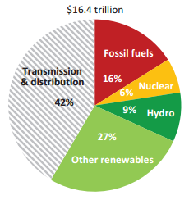For the global power sector, the International Energy Agency estimates that $16.4 trillion of investment will be made; transmission and distribution is expected to account for $7 trillion under their New Policies Scenario from 2014-2035 (in 2012 US$).[5] See Figure 1.1. The Edison Electric Institute estimated that the total infrastructure investment in the United States will be between $1.5 trillion and $2.0 trillion; transmission and distribution is expected to account for about $900 billion by 2030.[6]

High temperature superconductivity (HTS) based devices have the potential to play a critical role in helping to transform the global transmission and distribution grid.

## 1.1 Superconductivity as a Solution

Superconductivity is widely regarded as one of the greatest scientific discoveries of the 20th century. This property causes certain materials, at low temperatures, to lose all resistance to the flow of electricity. The lack of resistance enables a range of innovative technology applications. As we proceed in the 21st century, superconductivity is creating opportunities for new commercial products, such as ultra-high efficiency electricity cables and electric machinery that can transform our economy and daily life.

“Ways to reduce additional issues with siting include the use of existing transmission line corridors…and even superconducting cables.”

*—U.S. Department of Energy,  
Quadrennial Energy Review, April 2015*

Superconducting technologies are already a proven job creator worldwide, contributing more than $5 billion per year to medical and high energy physics industries, but there is a potential for several times this amount for power applications in the clean energy field.[7],[8] Currently, the major commercial applications of superconductivity involve low-temperature superconducting (LTS) materials and high field magnets, and are in the medical diagnostic, high energy physics, scientific and industrial processing fields. HTS greatly reduces the energy needed to keep the superconductor cool, making applications potentially more economical. HTS-based equipment can reduce energy losses, increase grid reliability, reduce right-of-way requirements, and alleviate grid congestion at a significantly lower cost than LTS-based applications. LTS devices are cooled using liquid helium to around 4 K and HTS can be cooled using a lower cost option—liquid nitrogen—to around 77 K.

In addition to its superior properties at relatively higher temperatures, HTS materials also come along with significantly expanded magnetic field capabilities. For several magnet applications such as analytical nuclear magnetic resonance (NMR) and High Energy Physics, these enabling properties are required for next generation equipment.

## 1.2 Value Added Over Conventional Grid Solutions

In developed countries, the electric grid has relied on traditional copper and aluminum conductors and other for more than a hundred years. These tried and true materials are well understood by the utility industry and are cost effective. HTS based cable and ancillary devices such as cryogenics are not well understood by the utility industry and generally cost more and will continue to cost more in the near future when compared to conventional solutions.

However, superconductor devices do not simply provide incremental improvements over conventional technologies; they provide unique solutions to challenges that cannot be achieved otherwise. Examples of electric power applications that provide these unique solutions include, superconducting fault current limiters (SFCLs), generators for off-shore wind turbines, and high-capacity power cables (See Table 1.1).

Table 1.1 Unique solutions from superconducting based devices.

|  |  |  |
| --- | --- | --- |
| **Challenges** | **Existing Solution** | **Superconducting Based Solution** |
| Reducing power electric system fault currents | Very limited | **Empowering renewables, distributed generation and clean energy sources.** These devices almost instantaneously “limit” fault current and then are ready for another surge. |
| Compact and light weight generators for >10 MW off-shore wind turbines | Very limited | **Energizing large-scale wind power with compact superconducting-based generators.** Superconducting rotor and stator coils provide compact and light weight generator and related nacelle design. |
| Transmitting high power through constrained rights-of-way | None available | **More power in smaller spaces – meeting high demand for electricity.** Retrofitting existing lines to carry 5 to 10x more power in a fraction of space compared to conventional technologies. |

Table 1.2 is an adaptation of data collected from a 2014 International Superconductivity Industry Summit (ISIS) Technology Scorecards.[9] ISIS is a worldwide group of superconductivity practitioners. The table shows qualitatively the relative position of HTS based devices compared to the most advanced conventional technology that exist on the electric grid. HTS based cables, fault current limiters, generators and transformers are analyzed against a number of key success factors. However, there are some gaps in the data and, therefore, not all four of these HTS based technologies were compared against every key success factor. The elongated shapes represent a varied response regarding the relative position. For instance, some data collected shows that operating costs for SFCLs were worse than conventional technologies while other data shows significantly better costs depending on the application.

The rows near the top of Table 1.2 are key success factors where HTS performs better or even significantly better compared to conventional technologies. Examples include maintenance after faults, fast response to fault currents, benefits to the grid, and overall compactness of the system. Some of the factors that HTS devices lag when compared to conventional technologies are indicated in the rows near the bottom of the table and include the initial investment cost, ability to conduct factory testing, long term reliability and scheduled maintenance.

Table 1.2 Relative Position of HTS Devices Compared to Most Advanced Conventional Technology.

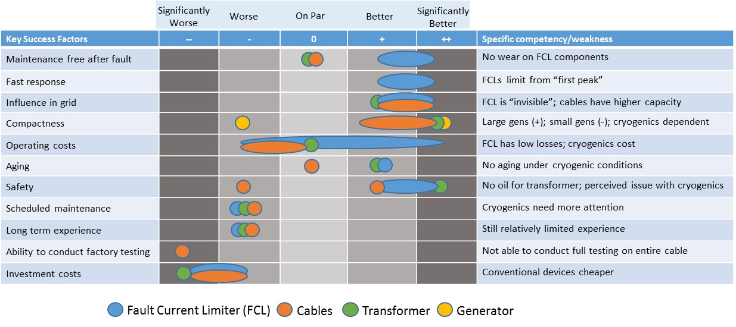

## 1.3 About the Roadmap

This Roadmap analyzes the current state of the superconductivity activities, lays out a vision for where superconductivity for electric power systems could be by 2030 and then identify the gaps for reaching this vision. Figure 1.2 is a summary of where the industry stands now and what some of the key challenges are that need to be overcome in order to reach the vision. These challenges are expanded on in Table 1.3.

There are several purposes and non-purposes of the roadmap document.

* Purposes of the roadmap
  + To describe the current state of the art and where the industry and other stakeholders are heading in the future;
  + To identify what the challenges and needs are for widespread integration superconducting based devices into electric grids across the world;
  + To educate decision makers about main benefits of HTS investments; and
  + To encourage adoption of HTS applications as part of both IEA and country energy strategy/initiatives to help modernize the energy sector.
* Non-purposes
  + To develop an exhaustive detailed list of projects around the world
  + To make predictions about future market characteristics

Figure . A Pathway to Reaching the Vision.

Table 1.3 Gaps/Challenges and Needs.

|  |  |  |
| --- | --- | --- |
| **Gaps/Challenges** | **Core Issue** | **Needs to Overcome the Challenge** |
| **Technical/Manufacturing** | | |
| **Raw materials cost-reduction** | * Multi-filament wires often use HTS filaments embedded in a silver matrix while so-called coated conductors are manufactured by depositing certain material, including silver, on a tape. | * Reduction of the amount of silver used in manufacturing several classes of HTS wires is a primary lever to lower the materials cost. * Reduction in the amount of Hastelloy or Ni-based metals for YBCO wire substrates in the case of $10/kAm cost-level. |
| **Quality control/in-line process control** | * Scrap wire against the ordered specifications: wire residual means extra labor and thus cost, and turnover of the factory machines will be lowered. * HTS materials are advanced composite materials that contain either very fine filaments of micrometer-size within a metal-alloy or multiple layers of metals and oxides down to nanometer-scale in addition to the superconductor material. * The purity of complex starting chemicals or powders, and the depositing condition are paramount to producing uniform filaments and nanometer thick layers. | * Precise control of the wire dimensions in processing and homogeneity of *I*c or other properties along the length or width. * Manufacturing yield would be significantly improved by the removal of small secondary particles or non-superconducting phases in the starting precursors that lead to either breaks or disruption in the current capacity in the final wires. * For fine filaments, evaluating filament uniformity is critical. High-throughput methods to control the quality of the precursors and deposited films will greatly enhance the manufacturing yield. |
| **Lack of standard testing facilities** | * Cooling to cryogenic temperatures accompanied by high current capacity at almost zero voltage is unique to superconductors and testing facilities and expertise are not readily available. * Thin film formed YBCO wire shows unique mechanical and electromagnetic behaviors of delamination and large screening current. * Variety of the test procedures in each HTS power device or in each developing institute. * Electric-grid applications require high reliability and undiminished product-performance over very long lifetime (30 to 40 years). | * Develop testing facilities with expert resource that can test mechanical stresses or high magnetic fields, in reel-to-reel systems over long lengths of wire. * Develop testing standard especially for film layered YBCO wire for delamination of the film and screening current effect. * Develop testing standards for HTS power devices. * The availability of facilities that can perform accelerated lifetime testing of wire, and components fabricated from wire, is essential to confirm reliability or guide product improvements. |
| **Interconnections for users** | * Superconductor wires used in large-scale devices must be joined to existing electrical connections, to each other (spliced), or to special terminations or current leads. * The joints and terminations must be robust at low temperature (i.e. withstand stresses due to cooling), have low electrical resistance and carry large currents. | * Manufacturing development of such joints, splices and terminations is important to facilitate adoption of superconductors into the marketplace as it will enable original equipment manufacturers to readily integrate superconductors into their systems and end-users install the overall device into its location. |
| **Cost and reliability of cryogenic systems** | * The ancillary cost for cryogenic cooling of the superconducting devices adds to the cost of the system. There is limited experience with operating HTS superconducting systems. | * Focus on cryogenic equipment, such as pulse tube and equivalent technologies, cryostat and insulation, to increase reliability and overall life cycle cost reduction. * Demonstration of complete, integrated cryogenic cooling systems that incorporate both the equipment and support infrastructure required for long-term, reliable operation. |

1.4 Scope of the Roadmap

Superconducting applications span a broad range of sectors in the world’s economy as shown in Figure 1.3. However, the scope of this roadmap will focus on applications for electric power systems. It is also important to note that the auspices of the IEA implementing agreement is on High Temperature Superconductivity and this roadmap will focus on this category of wire. However, there are still important partners and product development underway in the LTS arena. In addition to the core components of HTS conductor and cryogenic systems, electric power devices include:

* Cables
* Fault current limiters
* Generators
* SMES
* Transformers.

Figure . Superconductivity has broad applications.

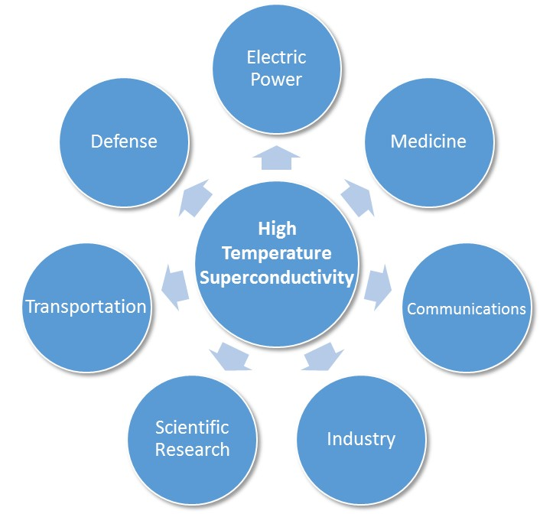

## 1.5 Sponsorship

The preparation of this report was sponsored by institutions in Canada, Finland, Germany, Israel, Italy, Japan, Korea, Switzerland and the United States. These institutions are signatories to an International Energy Agency (IEA) Implementing Agreement, entitled *Implementing Agreement for a Co-Operative Programme for Assessing the Impacts of High Temperature Superconductivity on the Electric Power Sector* henceforth referred to as IEA IA HTS.

## 1.6 Roadmap Methodology

Figure 1.3 below shows the methodology used to develop the roadmap. This process was adapted from the International Energy Agency roadmap process.[10] Work included developing purposes and non-purposes and adhering to a clearly defined scope of the technologies.

Figure 1.3 Roadmap Development Process.

Next, a standard data collection instrument, or survey, was developed in order to collect information from expert stakeholders. This survey was reviewed by IEA IA HTS executive committee to ensure that it contained the appropriate amount of detail and would yield the required information.

The next step was to collect information from expert stakeholders using several methods. The primary method was disseminating the survey to key stakeholders in the HTS community. Care was taken to get a cross section of respondents from across the world using several data collection methodologies. In some cases, in-person and telephone interviews were conducted to gather additional information from the respondents. The survey was sent directly to approximately 100 targeted experts in the field and also distributed through the Superconductivity News Forum (SNF) http://snf.ieeecsc.org, which reaches about eight thousand superconductivity specialists around the world. Data were also collected from various meetings across the globe including Applied Superconductivity Conference in Charlotte, NC, USA in August 2014; The IEA IA HTS Executive Committee meetings in Milan, Italy in June 2014 and Jeju Korea in December 2014; and the 27th International Symposium on Superconductivity (ISS) November 2014. Data were also collected from publically available websites and other published journals.

After collecting the data, it was analyzed and categorized into several key technology areas including wire, cryogenic systems, cables, superconducting fault current limiters, off-shore wind turbine generators, superconducting magnetic energy storage (SMES), and transformers. An analysis of each of these areas started with an assessment of the current state of the technology, technology targets to reach more widespread adoption, and R&D needed to reach these targets. The technology areas form the basis for the subsequent chapters in this document.

# HTS Wire

The first superconductor which operates at liquid helium temperatures (4 Kelvin), was discovered in 1911. Subsequently, low Temperature Superconducting (LTS) technology started to become commercially successful in the 1960-70’s when wire was made from LTS materials for use in superconducting electromagnets. LTS electromagnets create fields that are much stronger than conventional copper based electromagnets.[11]

Notably, these state-of the-art LTS electromagnets enabled new technologies like Magnetic Resonance Imaging (MRI) and Nuclear Magnetic Resonance (NMR). LTS superconducting wire is in general manufactured with Niobium Titanium (Nb-Ti) or Niobium Tin (Nb3Sn) using a well-known stacking & extrusion process, embedded in a non-superconducting matrix, such as a copper alloy, somewhat similar to the way traditional wire of copper or aluminum is made. Though LTS wire can be manufactured at costs competitive with copper, LTS devices are very expensive due to the high cost of cryogenic cooling at 4 Kelvin. As a result, LTS technology remains quite limited to niche and specialized applications (e.g. fusion and high energy physics applications such as the Large Hadron Collider and healthcare products such as MRIs) and is not conducive for energy applications.[12]

High temperature superconducting (HTS) wire is the key enabler of making devices for the electric power system that are more efficient and resilient than conventional solutions.[13] BSCCO, known as first generation (1G) HTS wire, and REBCO, known as second generation (2G) HTS wire, and Magnesium diboride (MgB2) are well-recognized types of superconducting wire. REBCO stands for “Rare earth - Barium - Copper Oxide” for the superconducting compound. We refer to REBCO hereafter as YBCO since Yttrium (Y) is the element most often used in 2G wire. While YBCO is typical in 2G wire, Gadolinium or Samarium are sometimes used to enhance critical current (*I*c) properties. BSCCO stands for “Bismuth - Strontium - Calcium - Copper - Oxygen." Each of these processes has been refined over time and there trade-offs for each type of wire. The temperature at which resistance ceases is referred to as the transition temperature, or critical temperature (*T*c). *T*c is usually measured in kelvin (K)—0 K being absolute zero. HTS gets its name originally because it has a higher transition temperature (77 K, which can be achieved when using liquid nitrogen) than LTS (around 4.2 K, which can be achieved using liquid helium). However, in this document we use HTS for MgB2 because it has a higher transition *T*c than conventional LTS.

*Superconducting wire is also referred to as tape.*

It is important to note that under the auspices of the IEA IA HTS, this roadmap concentrated on Bi2223 (a type of BSCCO wire), YBCO and MgB2 wires. While other wire development efforts are no less important to the general development of superconducting applications, Bi2223, YBCO and MgB2 wires are the leading type of wires under development and used in HTS devices for electric power applications.

Wire cost is important because it comprises a significant share of the device for electric power applications. For example, an HTS cable cost estimation study revealed that the HTS wire cost is more than half of the total cable.[14] Also for HTS generators, the wire cost of an HTS 10MW wind turbine amounted to a large percentage in the total system.[15]

## 2.1 Current Status

Bi2223, YBCO, and MgB2 continue to make improvements in performance and cost reduction. Furthermore, there are more than 15 wire manufacturers across the world from which device makers can buy HTS wire. This is an increase from a handful of manufacturers in 2010. Bi2223 wire, developed by SEI (Sumitomo Electric Industries, Ltd.), has been produced for several devices, mainly cable projects. YBCO wire has at least four companies that have delivered more than 10 km for various projects. MgB2 wire has two major companies; one in the United States and the other in Italy. Due to the simple fabrication process and low cost, they can produce a large amount of wire for MRIs or other applications.

Table 2.1 shows the companies who supplied already (as of May 2015) more than ten kilometers of HTS wire. A short description of the wire fabrication methods listed in the table is on the next page.

Table 2.1 Examples of HTS Wire Companies.

|  |  |  |  |  |
| --- | --- | --- | --- | --- |
|  | | | | |
| Company | **Wire** | **Country** | **Example Projects** | **Methods** |
| SEI | Bi2223 | Japan | Cables | Powder-in-tube |
| AMSC | YBCO | USA | Cables, SFCL | RABiTS/MOD |
| Superpower/ Furukawa | YBCO | USA/Japan | Cables, SFCL | IBAD/MOCVD |
| Fujikura | YBCO | Japan | High-field magnet | IBAD/PLD |
| SuNAM | YBCO | Korea | Motor | IBAD/RCE |
| Columbus | MgB2 | Italy | MRI | Powder-in-tube |
| Hyper Tech | MgB2 | USA | MRI | Powder-in-tube |

In addition to those in the table above, there are several other YBCO companies:

* **Bruker** HTS (Germany) using the IBAD/PLD (Ion Beam Assisted Deposition/Pulsed Laser Deposition) method
* **SWCC** (Showa Wire and Cable Company, Japan), IBAD/MOD (Metal Organic Decomposition)
* **SEI** (Japan), PLD/RABiTS (Rolling Assisted Bi-axially Textured Substrates)
* **STI** (Superconducting Technologies, Inc., US), IBAD/Reactive Co-evaporation Cyclic Deposition and Reaction
* **SuperOx** (Russia), IBAD, RABiTS/PLD; Rosatom-Kurtchatow (Russia), IBAD/PLD
* **THEVA** (Germany), Inclined Substrate Deposition)/e-beam Evaporation
* **Deutsche Nanoschicht** (Germany), Chemical Solution Deposition/RABiTS

These companies are now making an effort to supply a large amount of wire to customers. Among them, STI, Bruker HTS and SuperOx have rapidly increased their ability to produce a large amounts of wire. STI released an announcement of the production of 750 km/year for this year (2015) and already delivered the wire to 31 users.[16]

Wire companies are beginning to tailor their products for various applications by adopting the processing and composition. For example, SuperPower has a lower temperature, high field wire composition for coil applications in addition to a higher temperature and self-field wire composition for superconducting FCLs and cables. In fact, one type of wire is not a one size fits all solution for all applications; the processes being used can be tailored for several application types.

### Wire Fabrication Methods

There are several wire fabrication methods for making high temperature superconducting wire. YBCO wire, for example, is made from multi-layers and each layer can be made by a different method. Figures 2.1 and 2.2 shows the typical outside appearance and the structure of the YBCO wire.[17],[18] YBCO wire consists of Hastelloy or nickel (Ni)-based metal substrate, oxide buffer layers to protect chemical diffusion or to get biaxial orientation effect between layers, and YBCO layers on top of them. Silver (Ag) and Copper (Cu) stabilizer layers are deposited on YBCO for thermal stabilization. The detail of the structure is varied slightly according to each fabrication method and the thickness depends on the requirement of the application such as critical current (*I*c). Some specific descriptions of wire fabrication methods are listed below.

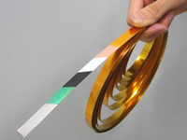Figure 2.1 Structure of typical YBCO wire by Superpower. *Courtesy of T. Fukushima, Furukawa.*

Figure 2.1 Typical YBCO wire.8 Courtesy of Y. Iijima, Fujikura.

Figure 2.1 Typical YBCO wire.8 Courtesy of Y. Iijima, Fujikura.

Figure 2.2 Typic Figure 2.1 Typical YBCO wire.8 Courtesy of Y. Iijima, Fujikura. Figure 2.1 Typical YBCO wire.8 Courtesy of Y. Iijima, Fujikura.

al YBCO wire.11

Courtesy of Y. Iijima, Fujikura.

igure 2.2 Typical YBCO wire.11

Cou Figure 2.2 Typical YBCO wire.11

Courtesy of Y. Iijima, Fujikura.

rtesy of Y. Iijima, Fujikura.

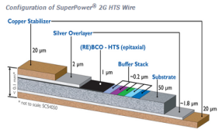

Figure 2.2 Structure of typical YBCO wire by Superpower. *Courtesy of T. Fukushima, Furukawa.*

The **powder-in-tube** process is used in Bi2223 and MgB2 wires. The raw materials of each superconductor, in a powder form, are put into a metal tube Ag in Bi2223 or iron (Fe) alloy in MgB2) and cold-worked to a wire or tape form. Subsequently, it is heat-treated at a given temperature to synthesize a superconducting phase and then exhibit superconducting properties.

**Rolling Assisted Bi-axially Textured Substrates** (RABiTS) was pioneered at Oak Ridge National Laboratory. It is one of the methods to make a textured metal (mainly Ni or Cu) substrate. After hard cold-working the tape form in a substrate processing, a pertinent heat-treatment develops a textured crystal of the substrate metal. This can be used to form textured layers through subsequent processing to grow epitaxial crystal in the buffer or superconducting layer deposition.

**Ion Beam Assisted Deposition** (IBAD), which was invented by Fujikura and subsequently by Los Alamos National Laboratory for MgO. During an oxide deposition like oxidized magnesium (MgO) or yttria-stabilized zirconium (YSZ), if an argon ion assisted beam is applied in a special direction to the oxide film growth direction, the MgO or YSZ films grow with a textured crystal growth on a metal substrate. Subsequently, a buffer layer or superconducting layer is deposited on top of a textured microstructure.

**Pulsed Laser Deposition** (PLD) is one of the superconducting layer synthesis processes. Pulsed laser is irradiated on bulk REBCO as a target and Rare Earth (RE), Barium (Ba), Copper (Cu) and their oxides will be sputtered or evaporated to a metal textured substrate such as IBAD or RABiTS substrate tapes.

**Reactive-Co-Evaporation** (RCE) is one of the superconducting layer synthesis processes. Each element of superconducting layer of RE, Ba, Cu is evaporated onto the textured metal substrate from the crucible in which each element is melted. The RCE system is now scaled for large batch or reel-to-reel operation with precise temperature or other parameter control to insure high superconducting properties.

**Metal Organic Decomposition** (MOD) is one of the superconducting layer synthesis processes. Chemical solutions of trifluoroacetates of metal elements of RE, Ba and Cu are used for superconducting phase synthesis and coated on the substrate layer. Subsequently, it is heat-treated in water vapor atmosphere. During the reaction, first precursors including RE, Cu and Barium Fluoride (BaF2) will be formed and textured superconducting REBCuOwill be obtained at the last heat-treatment stage.

**Metal Organic Chemical Vapor Deposition** (MOCVD) is one of the superconducting layer synthesis processes. The source materials of metal organic of RE, Ba and Cu are used for the precursors and they are transported to a textured metal substrate in a gaseous state. On top of the substrate, they are reacted chemically to synthesize a superconducting phase.

For industrialization, many of the above processes of IBAD, PLD, RCE, MOD and MOCVD apply a reel-to-reel system to make a long superconducting tape continuously.

### Main Wire Properties

The most important properties for are described below for Bi2223, YBCO, and MgB2 wires. These properties include the fabrication method; cross section and dimensions; and critical current (denoted as *I*c with the unit of A, Amps as a function of magnetic field (denoted as B with the unit of T, Tesla) at various temperatures. Depending on the application, the wire may operate at different temperatures and fields. For instance, cables, SFCLs, and transformers generally operate at 77 K at lower magnetic fields; generators operate at 20 K to 77 K at medium magnetic fields; Superconducting Magnetic Energy Storage operates at 20 K to 77 K at higher magnetic fields.

|  |  |
| --- | --- |
| **Bi2223 Wire** **Specifications**[19]   * Fabrication Method: Powder-in-tube and Ag alloy sheath * Cross section and dimensions: Flat tape with thickness of 0.23 mm and width of 4.3 mm * *I*c – B property: The tape has *I*c around 200 A at 77 K and self-field. 200 A are kept at 1.5 T for 40 K, 10 T for 20 K. At 4.2 K *I*c are around 500 A at 9 T as shown in Figure 2.3 below. The figure shows the relationship between the external magnetic field expressed in Teslas (T), the temperature (K) and the critical current (*I*c). Critical current decreases with higher external fields; it also decreases with higher temperatures.     Figure 2.3 Typical *I*c-B characteristic of Bi2223 tape. *Courtesy of T. Masuda, SEI.* | |
| **Advantages** | **Disadvantages** |
| * Most delivered and used for many large projects including long cable projects. * Successfully demonstrated long length more than 1 km. * Highest *T*c compared to other wires. | * Noble metal (silver in matrix) used more than in YBCO. MgB2 doesn’t use silver. * Lower *I*c in a magnetic field at 77 K, compared to YBCO. |
|  | |
| **YBCO Wire Specifications**   * Fabrication Method: physical or chemical deposition methods such as IBAD, PLD, MOD, RCE. * Cross section and dimensions: The most striking feature of this wire is the stacked and well textured structure (see Figs. 2.1 and 2.2 above). This structure is needed for the high *I*c (critical current) in YBCO, which requires a high degree of crystal orientation. An epitaxial growth phenomena is used in the film deposition process for the high degree of orientation.   YBCO wires have a width of 4—12 mm, and thickness of 0.15—0.4 mm in total including the substrate and all layers. The YBCO layer thickness is typically 1—2 μm and can be up to 5 µm. These thickness values can be important for the mechanical strain calculation or thermal stabilization.   * *I*c–B property: Today’s commercial wire shows a typical *I*c of 100—250 A at 77 K and self-field for 4—5 mm wide tape, or 300—500 A for 10—12 mm tape, depending on the company.[20]   A typical *I*c-B characteristic of a commercial YBCO wire is shown in the reference[21], where the vertical axis is the ratio by *I*c at self-field and 77 K. If the tape has *I*c at 77 K and self-field of 200 A, this value will be kept at 50 K and 4 T, and 30 K and 9 T. | |
| **Advantages** | **Disadvantages** |
| * High *I*c at high fields and high temperatures * High strength due to Hastelloy or other strengthened substrate * Processes and composition can be tailored/controlled for various applications that require different temperatures and magnetic field ranges. | * Currently more expensive than Bi2223 and MgB2 * Mechanical problems such as delamination and large shielding current (both come from the thin film and wide film configuration) * *T*c lower than Bi2223 |

|  |  |
| --- | --- |
| **MgB2 Specifications**[22]   * Fabrication Method: Powder-in-tube (in-situ or ex-situ methods) * Cross section and dimensions: Round wire and flat tape with multi-filaments. Typical sizes are in Figure 2.4 below. As shown in the figure, MgB2 makes up about 10% of the total materials used. * *I*c–B property: *I*c of 100—300 A can be transported at 1—1.8 T at 20 K. Further improvement is ongoing in the above companiesas well as national institutes.[23]     Figure 2.4 Round wire (left) and rectangular tape (right) of Columbus MgB2 wire. *Courtesy of Columbus.* | |
| **Advantages** | **Disadvantages** |
| * Low cost, light weight, and can be manufactured to long lengths * Transport properties and architecture very similar to LTS | * *T*c about 39 K * Lower *I*c at elevated temperatures when compared to YBCO * Application presently limited to below 5 T at 20—30 K and below 15 T at 4.2 K |

## 2.2 Wire Targets

Table 2.2 shows the perspective for the stages toward market maturity. The dots in the table were from data collected by the questionnaire, direct interviews or published materials and conference data (black represents YBCO; orange is Bi2223; green is MgB2).

For YBCO, the period of market-adoption that each respondent expects is mostly 2030, about 10 years later than those of other wires. Although YBCO wire has superior properties compared to others, the market, especially for electric power system, is challenging. Wire manufacturers are conducting R&D to improve the properties and reduce the cost of the wire. Another way to reduce the wire cost is with a large manufacturing order. This is a “Chicken and egg” problem where you need a large order to lower the cost, but you may not receive an order if the cost is too high. However, one company is now aggressively investing manufacturing equipment and plans to do rapid mass-production in the next five years as shown in Table 2.2.

Currently, Bi2223 and MgB2 are in the Initial Market Penetration or Mass Production with Improvement stages. This is partially because the start of the long-length- wire fabrication was earlier than YBCO and their powder-in-tube production process is simpler than YBCO’s.

More than 15 wire companies are actively conducting R&D worldwide and increasing their production capacity. Cost and capacity data were difficult to acquire in some cases since it could be business sensitive. While the data depicted here seems limited, the world-wide production capacity is certainly increasing to meet application-side demand.

Table 2.2 Technical Characteristics for HTS Wire.



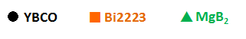

Manufacturers of Bi2223 and MgB2 can supply more than 1000 km/year. The main goal is continuing R&D to increase the performance characteristics and reduce wire price. However, comparing the *I*c-B characteristics of the wires, in general Bi2223 and MgB2 need longer length wire than YBCO to generate the same magnetic field for coils or magnets.

Table 2.3 shows the projected price and the production capacity of Bi2223, MgB2, and YBCO wire. The currency exchange rate is USD : EURO = 1.1 : 1 and others are applied the rates as of May 2015.[24]

There were many replies from the wire companies regarding their capacity today, however, some respondents did not provide data for 2025 and 2030 in Table 2.3. This could be related to their investment plan in the future, which would be dependent on their business forecasts.

In the tables, *I*c values for the price unit in kAm are for 77 K and self-field for Bi2223 and YBCO, and for 20 K and 1—2 T for MgB2. When using YBCO wire at various temperatures and magnetic fields, the *I*c value at 77 K and self-field (for cables and SFCLs) corresponds to *I*c at 30—50 K and 2—5 T (for generators), and *I*c around 15—20 K at 10—15 T (for SMES) for commercial wires.[25]

Table 2.3 Price and Capacity for HTS wire. 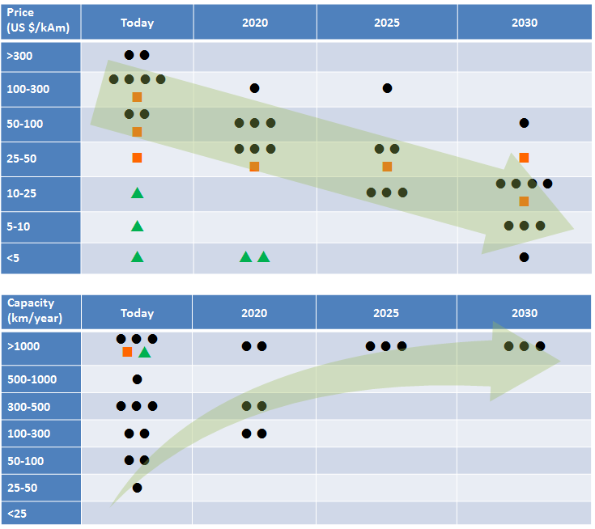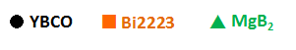

|  |  |  |
| --- | --- | --- |
|  | **Current Price** | **Target Price** |
| **YBCO** | * 100 to over 300 $/kA-m (black dot) | * $10/kA-m in 2030 |
| **Bi2223** | * 50 to above 100 $/kA-m (orange square) | * half of current cost in 2020 and gradually lower afterwards |
| **MgB2** | * 5—25 $/kA-m (green triangle) | * less than $5/kA-m |

The price difference is discussed in the three summary points below.

1. While Bi2223 is less than the present price of YBCO now, this trend appears to have a limit, due to the use of Ag and its stock market fixed cost. If YBCO costs can be reduced as expected, the price parity point with Bi2223 will be around 2025. However, in order for this to occur, the material cost, such as Hastelloy in YBCO, needs to be reduced (see discussion point 3 below), or the performance has to be increased (this would be even more effective), or the manufacturing cost share has to be reduced through economies of scale.

2. MgB2 already achieved relatively low price, but based on the data collected, it can be reduced further to less than $1-5/kA-m in 2020. However, MgB2 cannot work at higher temperatures than 30 K, but below 20 K and at medium magnetic field is the competitive application region with YBCO and Bi2223. In the future, the preferred region of temperature and magnetic field may be clarified for each kind of wires, depending on the cost and property.

3. If the target for YBCO, for example, is $10/kAm, the Hastelloy or Ni-based metal used for the substrate could be a problem since it is expensive compared to other metals like Cu. For example, a 200 A tape costs $2/m at $10/kAm. Normally the raw material cost would be 1/3 (or less, depending on the sales products), which is approximately $0.70/m. Reducing the raw material cost, of hastelloy for instance, is something the wire manufacturers do not have control over. Therefore, substituting this metal or using a thinner substrate (Superpower has made 30 micron thick substrate[26]) will be effective for the commercial stage.

Table 2.3 also includes the data for production capacity. The data shows that Bi2223 and MgB2 manufacturers can produce more than 1000 km/year now; some YBCO manufacturers have already reached more than 1000 km/year and others may reach this value by 2020-2025.

The companies that have achieved already 1000 km/year or have the equipment corresponding to this (see also the left hand side column in the Table 2.1) include:

* One company in Japan developing Bi2223
* One company in Japan, two in the US, and one in Korean YBCO, another US company could achieve this capacity very soon
* One company in the EU and one in the US developing MgB2

## 2.3 R&D Issues

Research and development is needed to continue to drive down the cost and improve the performance characteristics for HTS wire. A summary of the R&D needs are discussed below for Bi2223, YBCO and MgB2 wire:

1. **Pinning property to increase *I*c in a magnetic field.** *Ic* is sharply decreased in a magnetic field. To suppress this decrease, the introduction of pinning centers are being intensively studied—especially now that it has succeeded in improving YBCO wire. Non-superconducting oxide columns or particles are formed during deposition of superconducting layer and this exhibits a high *Ic* in a magnetic field.[27],[28] The normal columnar state (pinning center) attracts the quantum magnetic flux vortices (meaning that the vortices are pinned) and increases the ability to resist the moving of the vortices by Lorenz force when current transporting in a magnetic field. This results in the enhancement of *Ic*.

The benefit of high *Ic* is that it decreases the size of the coil needed to generate magnetic fields. Smaller coils reduce the size of the application. Many researchers have been studying pinning properties to try and increase *Ic*, which will ultimately help reduce the size of electric grid applications.

**2) AC loss reduction.** AC loss reduction is also very important for power applications. In AC power distribution, the current is constantly changing in direction, and in magnitude, continuously varying between its peak and minimum value. At any instant in time, the thermal losses in a cable are proportional to the current flowing in the cable at that instant. However, even in superconductors, heat loss will occur. In some case, the AC loss will share a significant amount of the total loss. For this reason, reducing AC loss is important for applications, because it will result in a smaller size of the cryogenics system, which will in turn lower the cost of the system.

**3) Tailoring of Wire.** There is a need to improve properties of *Ic* or AC loss according to the application requirement or environment of magnetic fields and temperatures. Wire manufacturers are making an effort to tailor the wire properties to match the application, while considering the cost accompanied with its improved process or composition. This kind of R&D strategy will be much more important in the future.

**Bi2223**

Cost: Since this wire contains high amounts of silver, reducing that amount, as well as the modification of the production process, is important. In addition, having a high *I*c without raising wire cost will be important.

AC loss: Ag between Bi2223 filaments is electromagnetically coupled and then the filaments couple each other, which increase AC losses.[29] To reduce AC losses, approximately ten years ago, the trial of the barrier around the filament of Bi2223 was popular to reduce losses because the barrier cut the circulating current.[30] However, the loss reduction has not been reported in a long sample. Workability with the complicated structure of the barrier seemed to be difficult.

Strength: Compared to YBCO wire, Bi2223 is not as strong because of the Ag matrix. However, hard Ni alloy was recently used and successfully enhanced the tensile strength from 100-200 MPa to 430 MPa, which is comparable to YBCO wire.[31]

**YBCO**

Table 2.4 shows the R&D needs for YBCO from the replies to our questionnaire. The numerical values in Table 2.4 are typical examples and will vary with the detailed requirement of the application and the design. The *J*c is defined as *I*c divided by the whole wire cross sectional area (superconducting layer, buffers, metal substrate and Cu layer) that is the so called engineering *J*c.

Table 2.4 Typical R&D Targets for YBCO from the Questionnaire Responses.

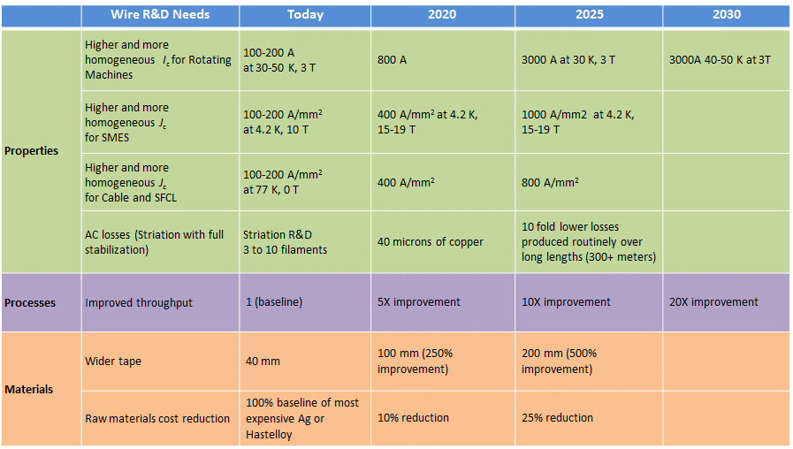

These R&D needs include:

* High *I*c with high homogeneity
* High throughput (cost effective production capacity)
* High yield (leading eventually to lower cost)
* Materials cost reduction: Ag, Hastelloy or other
* AC loss reduction
* Cost effective methods for quality control and system testing
* Improved processing for development of pinning centers, to tailor the properties for use in various magnetic fields (for *I*c in B)

High *I*c with high homogeneity: High *I*c will help increase the range of applications and contribute to lower cost in terms of the unit kA/m. This means that if a manufacturer fabricates 100 A wire, the wire has thinner YBCO film (low cost) at a higher production speed (low cost). Similarly, high *J*c is also effective for cost reduction, and is required for high field uses such as SMES and generators because normally the space of the magnet is limited. Therefore, higher *J*c can generate higher field in the same space.

High *I*c should also help keep the cost low. High transport current, for example above 1000A, needs a large amount of Cu stabilizer for protecting against burning out during the quench phase. If the Cu amount or other factors bring about high cost, it would not be acceptable in the market (except parts of it). Similarly, when considering high *I*c, if the thickness of YBCO film increases with *I*c increase, namely deposition time increase, throughput decrease and then the cost would increase. This should be avoided even when studying high *I*c R&D.

To increase *I*c in a magnetic field, the most popular method is to add effective and homogenously distributed artificial pinning center, for example by introducing oxide non-superconducting particles or columnar defects in the YBCO matrix. This causes a dramatic increase *I*c in a magnetic field.[32],[33]

AC loss: Using a striation method has been found to be effective to achieving AC loss reduction. However, striation is basically effective in YBCO film type conductor. At present, some institutes, such as ISTEC and University of Houston are conducting R&D to reduce AC losses, for example, by laser scribing method.[34] Striation can reduce AC losses according to the number of the divided sections or area. AC loss in a magnetic field comes from hysteresis loss during the field history and relates to the area of the film. As shown in Figures 2.1 and 2.2, YBCO wire has a wide area which generates a large loss and then striation is effective to reduce loss. Furthermore, to solve the eddy current and combined current losses problem in AC use, new types of conductor such as Roebel conductor (not a single wire) are being developed.[35] In both cases (striation and Roebel), we need feasibility study of a larger coil or system to confirm that those techniques can be utilized and thus to be improved its properties and homogeneity.

**MgB2**

*I*c in a magnetic field (>2T) and at operating temperature of 20-30K should be increased to enable use in larger range of applications. For this purpose, National Institute for Materials Science, Japan, HyperTech and Columbus are making an effort to increase *I*c property using a modified production method or raw materials.[36] However, this HTS wire is already used in a commercial product of the low field MRIs.

## 2.4 Summary

Wire development has made significant progress over the years to improve performance and reduce costs. Furthermore, there are more manufacturers making HTS wire. Bi2223, MgB2 and some YBCO companies have the capability of producing 1000 km/year, which is sufficient to develop large scale power applications. However, for further commercialization and market penetration, lower cost and improved properties of the wire will be important. Table 2.5 provides a summary of the HTS wire status.

In the United States, an Advanced Superconductor Manufacturing Institute was just announced.[37] This Institute will be working to develop projects that will address technical challenges that have limited the manufacturing capability of superconductors.

While wire development is a critical element of moving HTS devices into the electric power sector, advances in application development are also required. These R&D challenges and needs are discussed in the subsequent chapters in this document.

Table 2.5. Comparison of YBCO, Bi2223 and MgB2 Wire.

|  |  |  |
| --- | --- | --- |
| **YBCO** | **Bi2223** | **MgB2** |
| * Around $10/kA-m is the 2030 price target to enable wide scale adoption of devices * For YBCO, any further R&D such as making striations in the wire and higher *I*c is important, but should not increase the cost within the above $10/kA-m to address high-volume market segments beyond niche markets | * Currently has a lower price in $/kA-m than YBCO (at least for power transmission line applications), but research and development is underway to further improve performance and lower cost | * Lower in price than YBCO and $1/kA-m is expected. * Especially high *I*c at moderate temperatures, high field is indispensable for MgB2 to enlarge its market. |

# Cryogenic Systems

One of the critical components of HTS devices is the cryogenic system. A key element of HTS cryogenic systems is the mechanical refrigeration unit, which is used in many HTS applications to operate in the temperature range of liquid nitrogen (77 K or -196°C) and gas/liquid hydrogen or helium (at and below 20 to 30 K). Cryogenic systems have been used in industrial applications for decades so there are significant lessons learned and best practices available. However, cryogenic systems used for HTS power applications are still relatively new and reliability is a concern because of the limited operating experience, especially in energy technology. In an HTS cable, for instance, the typical components of cryogenic systems include the outer housing or cryostat, and a liquid nitrogen supply and return. Utilities and other end users are not familiar with this type of technology. Industry is working on improving the reliability of these systems, reducing cost and increasing end-users familiarity with these systems.

## 3.1 Current Status

Table 3.1 shows the typical cryogenic systems used for superconductor applications.[38] The Gifford-McMahon (GM) system is most widely used for commercial products such as MRI machines because it has a relatively long maintenance free period of about 10,000 hours. Pulse-tube systems are potentially very reliable because they have no moving parts. Turbo Brayton systems are being developed for the power applications and discussed later in this chapter.

Table 3.2 HTS applications and the required cooling power.

|  |  |  |
| --- | --- | --- |
| **Applications** | **Required Cooling Capacity** | |
| Cable | 2-20 kW | at 65-77 K |
| Motor | 2-5 kW | at 65-77 K |
| Transformer | 0.5-5 kW | at 65-77 K |
| SFCL | 0.5-2 kW | at 65-77 K |

Table 3.1 Typical cryogenic systems, operating temperature and cooling capacity.

|  |  |  |
| --- | --- | --- |
| **Cryogenic System** | **Working Temperature (K)** | **Cooling Capacity (W)** |
| GM | 4-100 | 0.1-600 |
| Stirling | 65-100 | 0.1-1000 |
| Pulse Tube | 4-100 | 0.1-1000 |
| Turbo Brayton | 4-100 | 100-100,000 |

Table 3.2 shows the typical cooling requirements for HTS power applications.[39] All the applications require more than 0.5 kW at 65 K to 77 K, which is the temperature range of the pressurized LN2 that many applications require. According to a recent report on cooling system, recent projected HTS system need the maximum cooling capacity of 20 kW for cable, 5 kW for motors and transformers and 1 kW for fault current limiters (SFCLs).[40], [41]

There are several applications operating below the liquid nitrogen temperature range. For example, HTS-SMES needs a high operating current, high magnetic field and low temperature. *I*c in the wire increases when the temperature is lowered. Therefore, R&D for HTS-SMES has been done at 20 to 30 K or below. Another example of an HTS application that needs lower temperature operation is generators. R&D for HTS wind turbine generators is being done around 20 K or lower. However, a whole system of HTS-SMES or windturbine including cryogenic system has not yet been performed. Therefore, more R&D is required to clarify the operating temperature requirements like the other devices in Table 3.2.

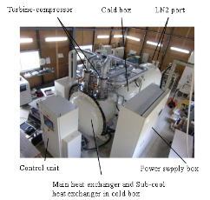

Figure 3.1 10 kW Neon Turbo Brayton Refrigerator. *Courtesy of S. Yoshida, Taiyo Nippon Sanso.*

Turbo Brayton systems are adequate for many applications including cables because of their large cooling capacity. R&D has recently been conducted on Turbo Brayton systems for large cable systems. In the U.S., Air Liquide developed a large capacity Turbo Brayton system for a cable project in 2010.[42] Around the same time, Taiyo Nippon Sanso developed a large Turbo Brayton system for the Japanese Materials for Power Applications and Coated Conductor (MPACC) project shown in Figure 3.1. This 10 kW system is commercially available.[43] Mayekawa recently reported the development of a large Turbo Brayton system for the TEPCO (Tokyo Electric Power Company) cable project with the power 5.8 kW and coefficient of performance (COP) of 0.1 at 77 K.[44]

Other than the example above, DH Industries, Inc., developed a high power and compact stirling cryogenerator, giving a total capacity of 12 kW at 77 K, for the U.S. Department of Homeland Security cable project in the US.[45] Goals of this stirling based cooling system, shown in Figure 3.2, were compactness and high reliability in an urban area.

 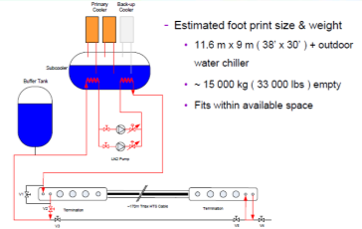

Figure 3.2 Stirling cryo-generator in the Resilient Electric Grid cable project.*Courtesy of J. Yuan, AMSC.*

## 3.2 Cryogenic System Targets

Table 3.3 shows the perspective and targets for HTS cryogenic systems. Most of the data collected is related to large power Turbo-Brayton cryogenic systems. Today there are 5 to 10 kW machines in the R&D stage and some units are being sold commercially outside government sponsored projects. Some companies anticipate the need for a 20 kW machine in 2020. In 2020 it is expected that 5 units/year could be sold and up to 20 units/year in 2030.

The data in the columns are from replies to the questionnaire. These forecasts are highly dependent on the progress of HTS cable deployment and cable projects. All data represented are for the Turbo Brayton system, except for those marked in green triangles, which are for Stirling and Pulse-tube. Those that are developing Turbo-Brayton systems expect the widespread market adaptation to be 2025 to 2030.

**Table 3.3 Commercial perspective of cryogenic systems.**



● **Turbo Brayton devices** **with cable at 5-10 kW at 65-70 K,** ◼ **Turbo Brayton devices** **with rotating machines,** ▲ **Stirling and Pulse Tube.**

## 3.3 R&D Issues

Table 3.4 summarizes the technical targets that should be met by conducting R&D. Among the data collected, COP coefficient of performance (COP) should be >0.09, maintenance interval or life-time >30,000 hours (about 3.4 years), cost $1.5 M in 2030 for a 10 kW cooling power capacity system.

Table 3.4 Cryogenic System R&D.

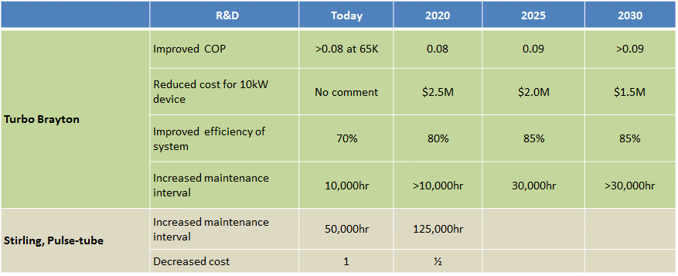

For Stirling and Pulse-tube systems, R&D is required to improve reliability and reduce cost as in the table.

Most of the challenges are focused on improving reliability and cost. However, the size of the system should be also reduced. According to data collected, the weight and size of the Turbo Brayton device is presently 2.8 tons and 2.3 x 1.5 x 2.5 meters, and should be reduced, particularly for densely packed urban areas. Cost, size, and reliability should be discussed in more detail with end-users such as utilities for a specific application.

**Other types of cooling system**

Figure 3.3 shows the cooling system of Ampacity HTS cable project, which uses a LN2 circulation system.[46] This is cost-effective because it does not need to use a large and expensive cryogenic system. Valuable data will be collected over time in this project to evaluate the system’s reliability and maintenance.

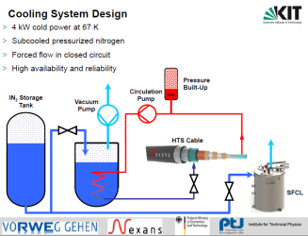

Figure 3.3 Cooling system layout for the cable and SCFL project in Essen Germany. *Courtesy of B. Holzapfel, KIT.*

## 3.4 Summary

Cryogenic companies are developing refrigeration systems for HTS applications and are gaining valuable data related to reliability and maintenance. This is particularly true with Turbo-Brayton systems for cable systems. Some have maintenance intervals >30,000 hours; however, cost and size still need to be reduced.

For other cryogenic systems, there was not enough data collected from the surveys except Turbo-Brayton to be able to present systematic perspectives like table 3.4. However, the following points are noteworthy:

* A cooling system consisting of a LN2 tank and circulation system are being demonstrated in the Europe because of its simple design and cost performance.
* A high power and compact Stirling refrigerator is being developing in the US for a cable system.
* The Gifford-McMahon cryocooler system is in the commercial stage in other fields (not HTS) and can be applied in the future for SMES (like Figure 7.1, 3 GMs there in SMES), wind turbine generator, SFCL and transformer. Suppliers could consider the future GM (for example, with higher power) in the commercial base.

# Cables

There are several key components of cables including the terminations, joints, cryogenic system and the HTS wire. The terminations are the equipment that allows the transfer of electric current between the ambient temperature and the superconductor. The joints connect sections of cable together; cables are typically manufactured and shipped in several hundred meter spools; if the cables are longer they will need to be spliced (joined) together.

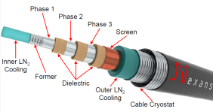Figure 4.1 10kV HTS three phase-coaxial type cable in Essen, Germany.*Courtesy of Nexans.*

Figure 4.2 TEPCO’s 66 kV cable project with three cores in one. *Courtesy of T. Masuda, SEI.*

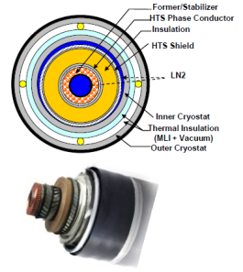

Figure 4.3 154 kV HTS single core type cable in Jeju, Korea.*Courtesy of S. Hwang, KEPCO.*

Cables require a cryogenic system to keep the superconductor cooled to operating temperature (typically 65 to 77 K). The cable itself includes the electrical conductor, electrical insulation, cryogen cooling, and the thermal insulation.

**HTS Cable Benefits**

* + - * Have increased efficiency; cables have the potential to reduce the amount of electricity lost in transmission and distribu­tion.
      * Can pack more current through available spaces. In congest­ed urban areas, expanding the capacity of an underground power line can involve digging up streets and can be expensive and disruptive.
      * Offer additional environmental and safety benefits. HTS cables may use liquid nitrogen as a coolant instead of the dielectric oil or SF6 commonly used in some conventional transmission-voltage cables, which can be hazardous, flammable, and potentially polluting.

## 4.1. Current Status

When combining the operating experience of all the cables in the world, there is more than 20 years of operating hours.[47] HTS cable projects have been energized in large scale grid demonstrations around the world. Nearly ten cable demonstration project are ongoing and are classified into 2 general categories:

* Distribution voltage; around 10 kV—66 kV
* Transmission voltage; around 66 kV—275 kV

Although DC cables are gaining more interest, this document focuses on AC cables because of the data available.

HTS cables carry more power at lower voltages compared to conventional cable technologies.

Examples of AC HTS cables are shown in Figures 4.1 and 4.2 for three phase-coaxial type and three cores in one, respectively. The former is used in the Ampacity project in Essen, Germany[48] and the latter in TEPCO’s Yokohama project in the Asahi substation in Japan.[49] Figure 4.3 shows a cross section sample of a 154 kV single core type HTS cable produced by LS Cables that will be located in in Jeju, Korea.[50] LS Cable also fabricates distribution voltage cables and developed a DC cable; they were tested at the Icheon substation and in Jeju in Korea.

Generally, the cable design depends on the voltage class and grid design of each country. Features from several of the developed cables include:

* A **three phase coaxial** type has been applied in distribution grids such as the Ampacity project in Germany (10 kV) and the Columbus cable in Ohio[51], United States (13.2 kV). 3 phase AC current flows coaxially and shields the magnetic field. The cable does not need a superconduting shielding layer as in single core or 3 cores in 1 type. (See figure 4.1)
* **Three cores in one** type is used in distribution voltage cables like the TEPCO cable project in Japan (66 kV), Icheon project in Korea (22.9 kV) and Albany, New York in the United States (34.5 kV).[52] Each core inside this type of cable is the same structure as the single type with superconducting current layer and superconducting shielding layer. 3 phase AC current can be transported in one cable and it will be more compact than the single type, which needs 3 cables. (See figure 4.2)
* A **single core** was used for a project in Long Island, New York[53] in the United States (138 kV), MPACC project in Japan (275 kV), and the KEPCO cable (see Figure 4.3) because the needed insulation layer for the high voltage is much thicker.

## 4.2 Cable Targets

Table 4.1 shows data collected from respondents on the current and expected commercialization status of cables around the world.

Analyzing these data leads to several points:

* Widespread market maturity could be expected around 2025 to 2030.
* Additional data not shown in the graphic indicate that the future target length is greater than 5 km while the today’s longest cable is the Ampacity project in Germany at 1 km.

Table 4.2 shows data collected from respondents working on cable projects as to their perspective on wire cost and required capacity. Each of the dots indicates a response. Highlights from this include the following application requirements:

* The cost requirement for wire is expected to be around $10/kAm by 2030
* Wire production capacity over 1000 km/year is required in 2020 to 2030

The cost target from cable manufacturers is the same as the wire manufacturer’s selling price as indicated in Table 2.3 for YBCO as well as Bi2223 (around $10/kAm).

The production capacity for wire will be required to be more than 1000 km/year mostly in 2020 to 2030. However, as seen in Table 2.3 in the Wire chapter of this document, some manufacturers of Bi2223, YBCO, and MgB2 can meet with this demand with today’s manufacturing capabilities.

Table 4.1 Commercial Perspective of Cable. 

● Distribution <30 kV, ■ Transmission >60 kV

Table 4.2 Cable requirement for wire cost and volume.

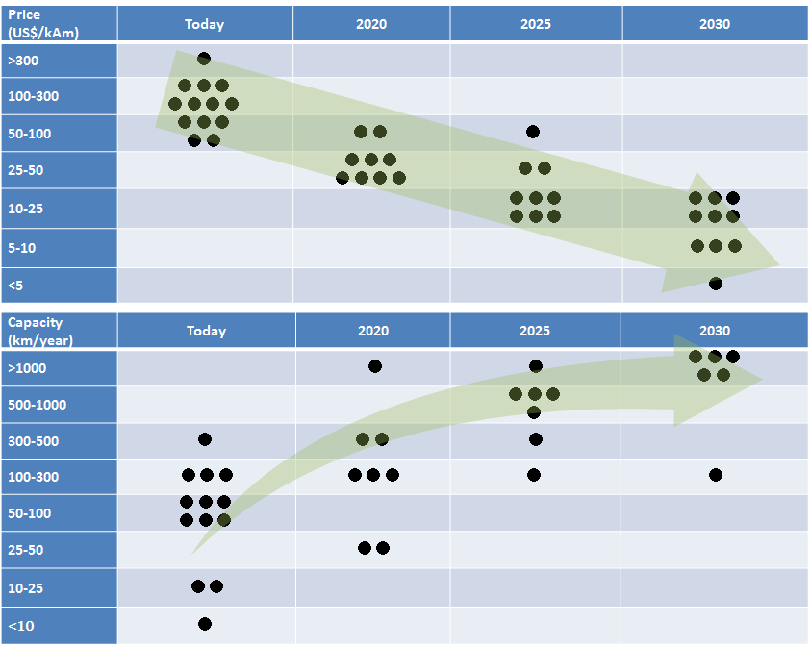

Table 4.3 shows the cable requirements for the properties of the HTS wire. From the survey replies, *I*c up to 1000 A/cm will be needed in the next step or next projects; today’s cable carries 2 kA to 3 kA with using today’s commercial wire (*I*c around 200 to 500 A/cm as in the wire section of this report). The data suggests that 1000 A/cm will be adequate in the future.

For the cryogenic system for the cable, as described in chapter 3, two main types of the cooling systems have been applied to HTS cables 1) LN2 by Stirling or Brayton devices with LN2 circulation or 2) Depressurized LN2 with LN2 circulation. As projects progress, valuable data will be collected to determine the benefits of each system.

Table 4.3 Wire requirements for cables.

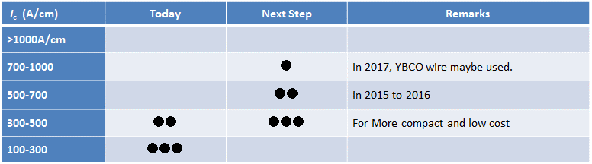

## 4.3 R&D Issues

There are several R&D needs for cables including 1) reduced cost of wire and cooling system, (i.e., lower capital expenditures) 2) improved cooling system characteristics such as COP (i.e., reduced operating expendatures), cooling power, reliability, and maintenance downtime, 3) AC loss reduction in the cables, 4) overcoming electric insulation and voltage problem such as withstand voltage, impulse voltage and 5) improved total reliability that enables a “fail free” system and easy operation. Table 4.4 shows the R&D needs with a baseline technical specification and out-year estimates. These are examples and will vary based on the requirements and design of the project.

Table 4.4 R&D Items for Cables.

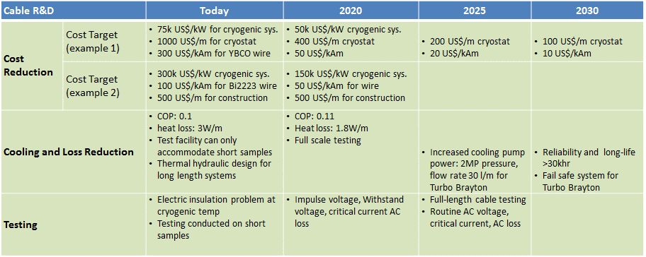

One respondent showed today’s specifications of $75,000/kW for cooling, $1000/m for cryostat and $300/kAm for wire and also the perspectives of the following:

* $50,000/kW for cooling in 2020 (half today’s cost)
* $100/m for cable cryostat (1/10 for the present cost) in 2030
* $10/kAm for wire (1/30 for the present cost) in 2030

Another respondent (cost target example 2 in Table 4.4) showed a difference in the cryogenic system cost; $300,000/kW at present and $150,000/kW (half of the present) in 2020.



Figure 4.4 Typical cryogenics cooling system. *Courtesy of N. Nakamura, Mayekawa.*

The difference between the two replies is 4 times ($75,000/kW vs. $300,000/kW) for the present cost of the cooling system. This may be due to the difference of the applied cooling system. As described before in Figure 3.3 in the cryogenic section, one project uses a LN2 tank and circulation system (open system) and the other uses large refrigerator and LN2 system (closed system). The former does not use the large, high power and expensive refrigerator, but it will need a long time operation to verify the reliability and maintenance cost. For our reference, Figure 4.4 shows a typical refrigerator and LN2 system using 1 kW Stirling refrigerator and LN2 circulation pump.[54] It is a closed system and may have less risk than refilling the LN2 during long cable operation. However, this requires a highly reliable cooling system.

According to a cost analysis for the case of a 10 km, 66 kV, 3 kA, three core in one cryostat, HTS wire cost dominates more than half of the cable.[55] This suggests that the cost reduction of the wire is the first priority in the cable application.

## 4.4 Summary

HTS cable projects around the world include 10 kV to 275 kV applications. According to the data collected, the commercial stage is expected in 2025 to 2030 with the following requirements.

* Reduce wire cost of about $10/kAm (about 1/30 of the present cost)
* Develop cryogenic systems over 10 kW @ 65 K (Turbo Brayton), under $1M, with improved COP, and heat load reduction
* Reduce AC losses, which can reduce the size of cryogenics system

Cable trends include:

* Up to now, Bi2223 has been the predominant material for HTS cables; several examples of YBCO based cables are being demonstrated
* Cable length is increasing, for instance the 1 km cable in Essen and 1 km cable in Jeju Korea have been demonstrated and a proposed ~5 km Resilient Electric Grid Project in Chicago was announced[56]
* Distribution voltage cables are being used for ongoing and planned projects
* Two major cooling systems are being used: 1) Stirling or Turbo Brayton devices with LN2 system and 2) sub-cooled LN2 circulation system
* Cable systems with inherently fault current limiting capability are gaining interest

|  |  |
| --- | --- |
| It is important to note that during the timeframe of this roadmap document (2015-2030), HTS cables will most likely cost 3 to 4 times more than the conventional cross-linked polyethylene insulated PVC sheathed cable, which are typical for utilities to use. However, HTS cables are being targeted for technical solutions that conventional cables cannot provide. For instance, in dense urban areas with limited space in cable ducts, HTS cables can provide additional power that conventional cables would not have been able to do since they take up more space (see figure 4.5). Additionally, HTS cables could prevent having to build a new substation. When comparing the costs of HTS applications such as cables, it is critical to include the entire system costs in the analysis. | Figure 4.5 HTS cables can transfer the same amount of power, but in a fraction of the space when compared to conventional cables. *Courtesy of Oak Ridge National Laboratory.* |

# Superconducting Fault Current Limiters

A superconducting fault current limiter (SFCL) limits the amount of current flow­ing through the electric grid and allows for the continual, uninterrupted operation of the electrical system, similar to the way surge protectors limit damaging currents to factories and house­hold devices.

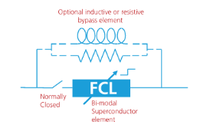

Figure 5.1 SFCL principle. *Courtesy of AMSC.*

The need for SFCLs is driven by rising system fault current levels as energy demand increases and more distributed generation and clean energy sources, such as wind and solar, are added to an already overburdened system. In some industrial applications, explosive fault-limiting fuses are utilized up to distribution level to limit fault current, but they require a service call to replace the fuse after it blows. Series reactors are also used but they have constant high reactive losses, are bulky, and contribute to grid voltage drops. SFCLs overcome these weaknesses. Additionally, rising fault current levels increase the need for larger and often costly high imped­ance transformers. However, in contrast to these transform­ers, SFCLs operate with little to no impedance during normal operation, which allows for a more stable system.[57] SFCLs offer numerous benefits to electric utilities as shown in the sidebar.

Currently, two broad categories of SFCL technologies exist—superconducting and solid-state. High temperature superconducting fault current limiters (SFCLs) use superconducting-based material and reduce fault currents by introducing at fault inception a larger-than-normal impedance into the path of the fault current (Figure 5.1).[58] Solid-state FCLs (non-superconducting based) use high-speed solid-state switching devices to rapidly insert an energy absorbing impedance into the circuit to limit the fault current.

**SFCL Bene**f**its**

* Utilities can reduce or eliminate these replacement costs from damaged circuit breakers
* Enhanced system safety, stability, and efficiency of the power delivery systems
* Reduced or eliminated wide-area blackouts, reduced localized disruptions, and increased recovery time when disruptions do occur
* Reduced maintenance costs by protecting expensive downstream T&D system equipment from constant electrical surges that degrade equipment and require costly replacement
* Improved system reliability when renewables and DG are added to the electric grid
* Elimination of split buses and opening bus-tie breakers
* Reduced voltage dips caused by high resistive system components
* Single to multiple shot (fault) protection plus automatic resetting

There are several types of SFCLs including resistive, inductive, and shielded core. This document focuses on the resistive type SFCL because many of the past or ongoing projects apply resistive type devices. In a resistive SFCL, the HTS material absorbs the fault current by quickly switching the HTS material from a superconducting state to a highly resistive state, which then limits the fault current. This transition occurs automatically and triggers the current to transfer into a current limiting coil or reactor. SFCLs have zero electric resistivity at a normal current transport state below *I*c. Meanwhile, when the faults occur in the electric grid, such as lightning or a downed power line, and a resultant large current (over *I*c) starts to flow, the SFCL instantly shows a high resistivity, automatically cuts off the high current and protect the devices downstream.

## 5.1 Current Status

SFCLs are one of the most studied devices among the HTS power devices. There are more than ten projects around the world—several examples are included in Table 5.1 below.

Table 5.1 Ongoing SFCL project in the world.

|  |  |  |  |  |
| --- | --- | --- | --- | --- |
| **Partners** | **Technical Specs** | **Location** | **Status** | **Notes** |
| RSE, A2A Reti Elettriche[59] | 9 kV, 220 A | Milan, Italy | De-energized for upgrade | Figures 5.2, 5.3 |
| Nexans, RWE, KIT[60] | 12 kV, 2300 A | Essen, Germany | Operational since April 2014 | Figure 5.4 |
| KEPCO[61] | 154 kV, 2000 A | Jeju, Korea | Under development | Figure 5.5 |
| NYSERDA, Applied Materials, Central Hudson Gas & Electric, SuperPower, Three-C Electrical[62] | 14.4 kV, 400 A | Poughkeepsie, New York | Operational since June 2014 | Figure 5.6 |
| Siemens[63] | 10 kV, 817 A | Augsburg, Germany | Commissioning early 2016 | Figure 5.7 |

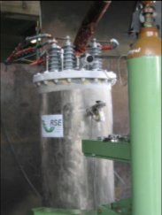 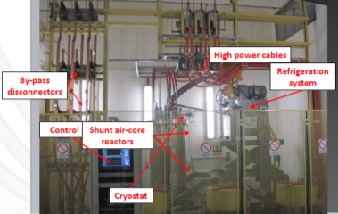

Figure 5.2 RSE’s SFCL undergoing short circuit testing (left) and system layout (right). *Courtesy of L. Martini, RSE.*

Figure 5.2 is an example of a SFCL developed by RSE (Ricerca sul Sistema Energetico - RSE S.p.A, Italy) and its integration in the electric distribution grid. The system consists of the SFCL (left figure), refrigerator, normal reactors and control unit. The superconducting current limiter element (winding) with coil form was installed in the cryostat and in LN2. The whole system is roughly, 2 x 3 x 3 meters, and operated in a substation in Milan Italy.

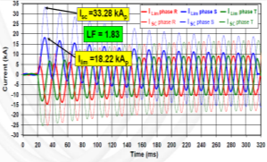

Figure 5.3 Actual data of current limiting of RSE’s SFCL. *Courtesy of L. Martini, RSE.*

This SFCL successfully operated for two years and experienced a fault current. Figure 5.3 shows the response to suppress the fault current of 33.28 kA to the safe current level of 18.22 kA.[64] Other SFCL projects are also shown in Figures 5.4 to 5.7.



Figure 5.5 KEPCO is testing a 1 phase SFCL (154kV-2000A). *Courtesy of S. Hwang, KEPCO.*



Figure 5.4 Schematic and Technical Parameters of the Nexans SFCL in Essen Germany. *Courtesy of Nexans.*

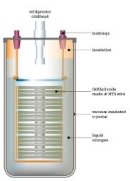 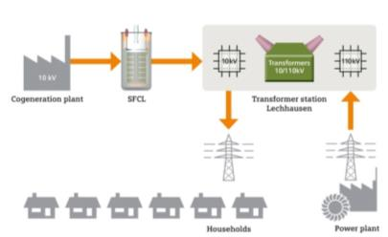

Figure 5.7 Siemens is developing a SFCL for use in the Augsburg Germany electric grid.The image on the leftis a schematic of the SFCL; the image on the right depicts where the device will operate on the grid. *Courtesy of T. Arndt, Siemens.*

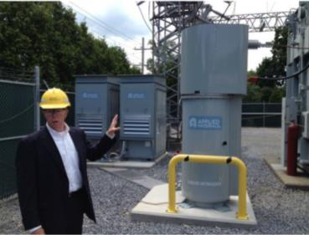

Figure 5.6 A SFCL (15 kV/400 A) operating in New York in the United States.*Courtesy of John Davis, Poughkeepsie Journal.*

## 5.2 SFCL Targets

Table 5.1 shows the perspective and targets for SFCL systems, where the main device is distribution voltage level SFCL (10 kV, 15 kV) and transmission voltage level SFCL (~154 kV). The period of widespread market maturity is 2025 for distribution voltage SFCL and later for transmission voltage SFCL.

There is research and development underway as well as some demonstrations in the field. Typical SFCL voltage classes range from 10 kV to 154 kV and reflect the situation in each area. At the distribution voltage classes, SFCL have the potential to be in a commercial stage as early as 2025, which is earlier than the cable survey result (2025 to 2030). Transmission voltage SFCLs are expected to take a longer time for market penetration because of the technical challenges listed below.

Table 5.2 Commercial perspective of SFCL.

● Distribution <30 kV, ■ Transmission >60 kV

## 5.3 R&D Issues

While very few respondents provided data for future R&D needs, several key areas should be addressed for future competitive products and higher voltage products.

* Improved *I*c homogeneity along the whole length of the SFCL’s current limiting winding. Current limiting should be occurred for whole of the wire, not concentrating on some parts of it which would results in the burning.
* Improved reliability, longer scheduled maintenance period and cost reduction for cryogenic systems
* Improved insulation for the reliability of the SFCL device. During the current limiting process, the device, needs to tolerate high voltage. As voltage is increased, this problem becomes more difficult to solve.

In an SFCL, normal state resistivity determines the current limiting level. Since YBCO wire a smaller amount of Ag compared to Bi2223, it has higher resistivity. Therefore, YBCO SFCLs will use less wire than Bi2223 based devices. However, YBCO wire needs additional stabilization in case of quenching or current limiting process over *I*c, that will cause the wire to burn out. For YBCO, the combination of its resistivity, current limiting level and stability make it more suitable for the design of SFCLs.

**Cost of the system and the wire**

Due to the limited amount of data collected from the questionnaire, additional information was collected regarding the system cost. For a distribution voltage type SFCL (6.6 kV/600 A), the wire cost is about 20% (assuming $120/kAm) of the entire system and the rest is for other factors such as SFCL winding fabrication, cryostat, and cryogenic system (largest one).[65] Other analysis conducted shows that for a 40 MVA resistive SFCL the wire cost is approximately 40% of the total cost of the system.[66]

**Standards development for SFCLs**

As mentioned in section 5.1, SFCLs are being developed and demonstrated worldwide in actual electric grid systems. To further promote the adoption of the SFCLS, standards for the performance, testing should be developed as discussed in Table 1.3. For instance, there is an IEEE Working Group PC37.302/D3 on Fault Current Limiter Testing. This group is developing a guide that describes the testing of SFCLs operating on condition based impedance increase for AC systems 1000 V and above.[67] This guide does not include constant impedance series reactors and single fuses.

## 5.4 Summary

The increased use of renewable energy and distributed generation is making power system operation more complex; however, this presents an opportunity for SFCLs. SFCLs are being studied in more than 10 projects around the world. Distribution voltage SFCLs are expected to reach the market earlier than transmission voltage applications.

There is still work that needs to be done to see broader adoption of SFCLs. For instance:

* R&D needs to be conducted to reduce the cost of the system (including “standardization”) and prove long term reliability of the system
* Communications and outreach must be done to help alleviate the issues with novelty of cryogenics for end users
* End users need to have a better understanding of the cost/benefit especially when extending the view from a component to a system perspective

# Generators for Wind Turbines

Demand for wind turbines is increasing because many country’s goals are to increase the percentage of electricity being produced by renewables. There is exceedingly high interest wind power—particularly off-shore wind turbines because there is a plentiful and reliable wind resource. However, large offshore wind turbines of 10 MW or greater require a huge support structure, larger turbine blades and larger generators compared to conventional land based devices.[68] Today’s machines produce 50 or 60 Hz power from shafts rotating at a fraction of a hertz by using a mechanical transmission or gearbox and a relatively inexpensive generator. However, both the unreliability of the gearbox and its weight deter developers from using this approach for higher power generators.

## 6.1 Current Status

Electric motors and generators are ubiquitous in many sectors of the world’s economy. HTS based machines have been investigated for several applications by companies like AMSC, Siemens, Doosan, KHI (Kawasaki Heavy Industry). While there is still interest in HTS motors, there is increasing interest in HTS based wind turbine generator applications.

Because superconductivity offers the possibility of a smaller and lighter generator than is possible with conventional materials, there is substantial interest for trying to eliminate the gearbox by building a multiple pole generator. For example, such a machine could convert shaft power at 1/6 Hz (10 rpm) to electric power at 2 Hz and then use power electronics to further increase the power’s frequency to network frequency, 50 or 60 Hz. In order for slowly rotating shafts to transmit high power, the shaft and the rest of the system must be capable of handling torques that are ten times greater than the highest-torque machine built to date. A larger generator dramatically increases the weight of the system that is farthest away from the support structure. The support structure will need to be significantly increased and there are potential limits from a mechanical stability point of view.

There is some experience within the HTS community with developing relatively low torque machines. While full scale prototype HTS generators for wind turbines have not been built, there are efforts underway to help move the technology to large scale applications.

A typical 10 MW HTS generator and turbine is shown in Figure 6.1 designed by AMSC.[69] Main specifications include a rated power of 10 MW, 24 poles, rotational speed of 10 rpm, and an operating temperature of 30—40 K. The generator consists of HTS superconducting field winding and copper armature winding with the diameter of 5 m. An HTS generator of this size is estimated to weigh 150—180 tons while the traditional copper-based generator is 300—500 tons.[70] A non-superconducting based 7 MW, offshore wind turbine is expected to be in operation in 2015 near Fukushima, Japan. This turbine, with a turbine blade diameter of 167 meters, would be the largest one installed.[71]

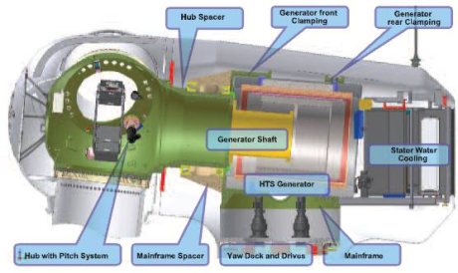

Figure 6.1 Schematic illustration of superconducting (YBCO) generator by AMSC.*Courtesy of AMSC.*

To date, there have been several design projects for large HTS turbines (more than 10 MW) by Converteam, AMSC, Riso DTU.[72],[73],[74],[75] From the data collected, the large HTS generator requires a high magnetic field of more than several Tesla and needs thousands of kilometers of the wire, for the case of a YBCO generator operating at 20 to 40 K and in an air core system.

R&D is being conducted on MgB2 based generators by the Advanced Magnet Laboratory in the United States and Suprapower, which is an EU based consortium of nine organizations.[76],[77] Figure 6.2 shows the concept design of Suprapower’s MgB2 HTS generator, which applies the direct drive system without a heavy gear system.

Recently, a new YBCO based generator system using iron core (not air core) has been proposed and studied for the purpose to reduce the wire amount and thus the total weight.[78] According to the initial study, the wire amount is 46 km and the total weight of the generator is half of the normal conducting generator.

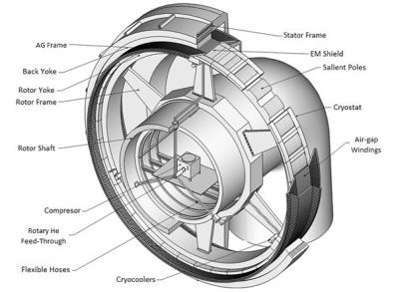

Figure 6.2 Schematic illustration of superconducting (MgB2) generator by Suprapower project. *Courtesy of Suprapower.*

A summary of the R&D status of HTS machines is listed in Table 6.1 below.[79]

Table 6.1 Overview of R&D Status for Superconducting Wind Turbines

|  |  |
| --- | --- |
| **Organizations** | **R&D Overview** |
| Siemens (Germany) | * 4 MW 3600 rpm generator and 4 MW 120 rpm motor were developed * HTS field windings for 10 MW HTS generator under development |
| “Suprapower” (EU) | * Co-funded research project (2012 - 2016) with 9 partners * Developing a 0.5 MW model HTS generator |
| AMSC (USA) | * 36.5 MW HTS motor was completed * Design study of 10 MW HTS generator was conducted |
| Brookhaven National Laboratory (USA) | * Conducted comparison of 10 MW HTS generator design topology * Developing design of >10 MW HTS generator |
| Universities (Japan) | * Tokyo University of Marine Science and Technology performed design and optimization of 10 MW HTS generator * Univ. of Tokyo and Niigata conducted design of 10 MW HTS generator |
| NEDO (Japan) | * Design of a 10 MW HTS generator (Oct. 2013 - May 2015) * HTS coil module and turbo-Brayton refrigerator were developed |
| Huazhong Univ.  of S&T (China) | * Conducted design of a 12 MW 9 rpm HTS generator |
| Changwon National Univ. (Korea) | * Conducted design of a 10 MW HTS generator |

## 6.2 Generator Targets

Table 6.2 shows the generator perspective and target for YBCO generators. Respondents generally felt there would be widespread market maturity to be around 2030. There is work underway on the design of the entire wind turbine and YBCO coil fabrication.

Table 6.2 Commercial perspective of generator (YBCO).



Table 6.3 shows the cost of YBCO wire and production capacity needed. By 2030, respondents noted that the wire cost should be at 25—50 $/kAm or 5—10 $/kAm and the capacity of more than 1000 km/year. Sales could reach more than 50 units in 2030 based on one of the responses. The difference of the cost in 2030 is due to the amount of YBCO wire in the generator; one is with iron core and the other, air core. Using an iron core, the field coil does not need to use a large amount of HTS wire, which has the potential to reduce the total cost. This means that higher cost YBCO may be competitive for this case.

Research has been conducted that outlines the cost effect of superconducting wire on wind turbine generators.[80] The cost of a 12 MW turbine should be around $20 M using projections of wire cost. In this research, the wire used is 375 km and the cost is $23/m (at *I*c = 100 A @ 77 K, self-field). Then, the total wire cost is $18 M; 90% of the above turbine cost ($20 M). The first priority is to reduce the cost of HTS wire; perhaps to less than 1/10 of the present cost.

Table 6.3 Generator requirement for wire cost and volume (YBCO). 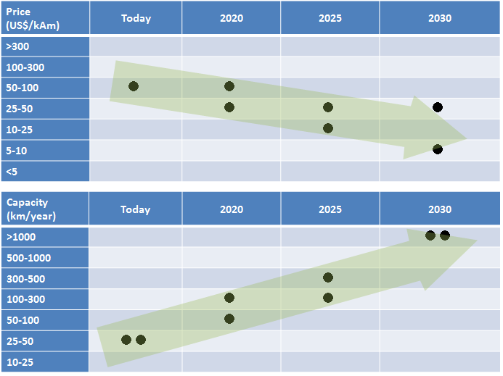

Several hundred km to 1000 km of wire will be used in one generator.[81] In order for wind turbine companies to produce several sets of 10 MW machines/year, the wire companies will need production capacity of several times 1000 km/year.

In the generator application, HTS will be used in the field-winding which can generate a high magnetic field. The HTS system will be smaller and lighter than the conventional normal conducting generator because of its high *I*c in a magnetic field. This is different from the cable and SFCL applications, which do not use any magnetic fields. Therefore, the *I*c of the HTS wire in a magnetic field is important in a generator use.

One respondent indicated that *I*c of greater than 1000 A/cm will be required while another indicated that the critical current did not need to be that high. For the magnetic field, the former would require around 2—5 T, but the latter requires less than 1 T. This is due to the difference of the iron core versus the air core system. While the iron core system does not need a large amount of wire because iron helps the magnetic field generation, the air core system can generate a high magnetic field and the size or weight will be smaller. A comparison of the two systems needs detailed designs together with the cost evaluations.

## 6.3 R&D Issues

Like in other HTS applications, R&D is needed to reduce the cost of wire, increase *I*c, and reduce AC losses.

* Improving the manufacturing yield of the HTS wire will help reduce cost.
* Increase *I*c at 3T: the magnetic field, 3T is an example, which depends on the design.
* Quality control, especially for *I*c, helps lead to low cost of wire.
* Lower AC Loss: multifilament is found to be effective but should not be expensive.

While the items above are the R&D related to the wire, the following are particular to the generator system.

* cooling system in a rotating machine
* race-track form coil (not uniform winding tension)
* coil in a rotating state (meaning the tolerance to the centrifugal force)

Industry has not yet started on these R&D items because today’s activities are just in the stage of a small coil fabrication using YBCO or MgB2; industry will need to scale up to large coils which can be directly applied to the generator system.

Table 6.4 is a typical example of the R&D issues from the questionnaire responses. Here the *I*c increase for the HTS wire is controversial; some researchers say that if *I*c is higher for example, the conductor will easily burn out when transport current is near *I*c and/or with a thermal disturbance. If enough Cu stabilizer is added, the conductor and thus the generator will be heavier and larger. This R&D issue is related to HTS wire and *I*c will be discussed together with the coil fabrication study, cooling method and the generator system.

Table 6.4 Typical Generator R&D Issues (YBCO). 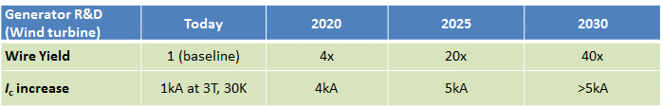

**MgB2**

The Suprapower project is studying wind turbine generators designs based on MgB2 wire.[82] The objective of the project is a low cost 10 MW turbine using MgB2. The wire costs $30/kA-m (meaning $3/m for 100 A wire, $6/m for 200 A). Therefore, the cost of the drivetrain (not the whole wind turbine system) would be approximately $2.8 M for a 10 MW machine. This is competitive, compared to the conventional wind turbines. Currently, Suprapower is studying MgB2 large coil fabrication for design of a 10 MW commercial device.

Similarly, HyperTech, a U.S. based company producing MgB2 wire, is studying a MgB2–based wind turbine[83] (see also the wire section, Table 2.3). According to their study, the wind turbine market entry cost for the wire could be 5 to 10 $/kAm. Hyper Tech anticipates low cost MgB2 at $1.5/kAm, which is less than the above wind turbine entry cost. Although these costs are much lower than predicted by Suprapower, HyperTech is wire supplier and may consider the low cost as a key for competition. In addition, a project for a low-cost wind turbine is on-going in Germany using advanced low cost MgB2 tape.[84]

## 6.4 Summary

YBCO and MgB2 based generators have the potential to be used in large offshore wind turbines 10 MW and above. The high power to weigh ratio for HTS based turbines has the potential to reduce the cost of the tower, foundations, floatation equipment and installation. This reduction could be significant as a 10 MW turbines tower height is designed to be 125 meters and the blade diameter of 190 meters.

Data collected from the survey shows that HTS based wind turbines could be commercial in 2030. However, to reach this stage the first priority is to reduce wire cost to compete with the present wind turbine generator market.

There are very few large coil or system studies for HTS generators for wind turbines (unlike cables or SFCLs). Today’s studies are looking at small or medium size coils using YBCO or MgB2 wire. In order to make an entire wind turbine system, R&D will be needed on the cooling system in a rotary environment and larger coils (field coil of generator) in a rotating state. Furthermore, as in other applications, reliability, safety, low AC loss and high *I*c are important in this application.

# Superconducting Magnetic Energy Storage (SMES)

Superconducting magnetic energy storage (SMES) technologies have the ability to store electricity in the magnetic field of direct current. SMES uses a superconducting magnet, which can generate a high magnetic field. This is possible because the current circulates in the resistance free superconducting coils rather than in the coils of copper other metal conductors, which have resistance. HTS wire is favorable for use in SMES devices because of its high *I*c or *J*c at a high magnetic field. SMES devices can provide several key applications including power, energy, and controlling phase of current.

There are several major subsystems for SMES devices. One is the energy storage subsystem comprising a superconducting coil and its containment. Another is the cryogenic subsystem comprising the cryostat and cryogenic and cooling system; a power conditioning subsystem comprised of power electronics that enable the energy storage device to discharge three-phase AC power of the desired frequency and phase and well as recharging from the electric grid.

## 7.1 Current Status

SMES applications differ in the amount of energy stored. For instance, the largest considered would store some 5,000 MWh, while the smallest would store 1 MW-second. They also differ in their power, which is the rate at which the stored energy can be discharged. The largest power currently being considered is 1,000 MW, and the smallest is 0.5 MW. SMES devices also differ in their ability to control the phase of the currents that guide their output power into the electrical network. These parameters—energy, power, and phase—makes SMES a candidate for several applications. There are several current and past SMES R&D projects that are listed below.



Figure 7.1 10 MW-10 MJ NbTi SMES. *Courtesy of N. Hirano, CEPCO.*

Figure 7.1 shows a SMES device made of NbTi wire.[85], [86] This 10 MW (10 MJ) device has been operating for several years at Sharp Corporation in Japan to protect their liquid crystal TV production line from electrical outages. The SMES device has protected the factory from black-outs caused by lightning many times since its installation. This type of SMES was installed in several other locations in Japan.

A system study of SMES was conducted in Japan until 2013 as shown in Figures 7.2[87] and 7.3.[88] A large NbTi SMES device was tested to provide grid compensation in a real substation. Subsequently, an YBCO coil was tested to and verified to enable high current and tolerate the resultant tensile stress. The coil in Figure 7.3 was 650 mm in diameter and showed the tensile stress of 1.7 GPa when transporting *I*c of 2.7 kA. These results showed YBCO wire is promising for a larger and a higher field SMES device of 2 GJ. Subsequently, however, there is limited R&D being performed in each related institutes.

**R&D Project for YBCO SMES in the United States**

* Demonstrated a small scale prototype (20 kW, 2.5 MJ)
* Project Partners: Brookhaven National Laboratory, ABB,   
  SuperPower, and the University of Houston
* Magnet designed for 700 amp, 15 T, 100 mm inside   
  diameter, 1.7 MJ at 4 K
* Testing complete to 250 amp, 12.5 T at 27 K – a record field for   
  HTS magnet at such a high temperature (>10 K)

**Figure 7.4 Example of SMES R&D. *Courtesy of R. Gupta, BNL.***



**R&D Project for YBCO SMES in Japan**

* Project dates: 2009-2013
* HTS coil 20MJ and design for 2 GJ
* Project partner: CEPCO
* Large HTS Coil tested: *I*op= 1500 A,   
  Hoop stress >1GPa
* OD = 240 mm, ID = 219 mm

**Figure 7.3 Typical SMES double pancake YBCO coil developed in the MPACC project in Japan.*Courtesy of N. Hirano, CEPCO.***



**R&D for Grid Power Stabilization in Japan**

* Project dates: 2004-2007
* 20 MJ, NbTi, Liquid He
* Project partners: CEPCO, Furukawa, Toshiba
* Operated at Nikko power plant
* >50,000 times test of power compensation

**Figure 7.2 LTS 20MJ SMES in Hosoo water power plant of Furukawa Nikko Power Generation Inc.**

***Courtesy of N. Hirano, CEPCO.***

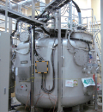

Figure 7.4 shows an example of a U.S. Department of Energy, ARPA-E project led by ABB for a 2.5 MJ 20 kW SMES device using YBCO wire. The project goal was to develop a competitive, fast response, grid scale MWh SMES system. A full SMES system was designed, built, and verification tested. This project advanced the state of the art considerably in the SMES system components – power electronics, magnet coil bypass/persistence switch, 2G HTS wire manufacturing enhancements.[89],[90] Along with the enhancement of the YBCO wire property, especially *I*c, the HTS coil fabrication is well developed and the coil exhibited a high magnetic field and high *I*c. Figure 7.5 shows that YBCO “pancakes” were successfully fabricated and demonstrated for the ARPA-E project showing superior properties such as high *I*c at 4 K and 27 K and controllable charge/discharge coil operation.[91] The pancakes were fabricated using approximately 6.7 km of 12 mm wide YBCO tape, which was developed in this project to enhance the *I*c.

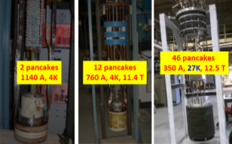

Figure 7.5 YBCO coil for SMES. *Courtesy of R. Gupta, BNL.*

## 7.2 SMES Targets

Table 7.1 shows the target for SMES devices. SMES devices are based on using YBCO or MgB2 wires.

Table 7.1 Commercial perspective of SMES.

**● YBCO,** ▲ **MgB2**

For YBCO, the data collected estimates that the widespread market maturity stage will be reached sometime around 2030. Some SMES researchers indicate that YBCO SMES will be more competitive than other energy storage products such as batteries, capacitors, and flywheel because YBCO wire enables a high field and compact SMES device.

The R&D plan for YBCO-based devices is considered, for example, to 1) start with a relatively small 1 MJ scale SMES device and then 2) scale up to 10 MJ class. It is expected that even a 10 MJ HTS SMES device will be competitive in the energy storage market and can scale up to 2 GJ for grid applications.

Table 7.2 is the requirement for the cost and capacity of the wire. Although there was only one response, they hope the lowest cost of the wire below $5/kAm and capacity more than 1000 km/year. Designs are being considered and studies are being conducted on the basics of YBCO SMES coil. There is only the need for a few 10’s of kilometers for the time being, but will require over 1000 km/year for the commercial stage.

Table 7.2 SMES requirement for wire cost and volume (YBCO).

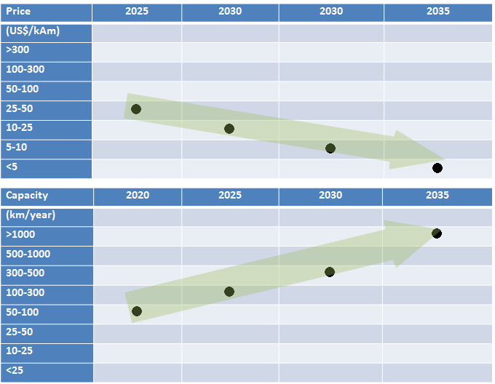

Examples of the requirement for the wire property and cooling for SMES include: Higher field than 10 T for YBCO SMES, *I*c around 500—700 A/cm and the operating temperature around 20 K. However, as later described in the R&D issues section, others experts replied that they need 3 to 5 T at 20 K and the *I*c ranges of 300—500 A/cm. The difference results from the various proposed designs of the SMES.

For MgB2, the widespread market maturity stage was not described in the survey responses. This is probably due to the absence of a large MgB2 coil or SMES project. It is premature to discuss the commercial stage of MgB2 SMES devices as more data needs to be collected. It is expected that MgB2 SMES devices can use liquid hydrogen (LH2) coolant, which could be available due to fuel cell–based vehicles and associated infrastructure.

## 7.3 R&D Issues

Table 7.3 shows some of the R&D needs for SMES devices. Several of the highlights include:

* Reduced cost of YBCO wire
* Increased *I*c at 3 T—5 T and 20 K, especially for MgB2 wire
* AC loss reduction and improved mechanical properties from YBCO conductor
* Reliability over long-term operation as a coil

A detailed study of a YBCO 20 MJ SMES device showed that it requires wire-length of 250—300 km, *I*c of 300 A at 11 T and 20 K, and 600 MPa of tensile stress tolerance with a refrigerator conduction cooled system.[92] This results in a compact YBCO SMES device 2.0 meters in diameter and 0.7 meters in height, much more compact than NbTi SMES (see Figure 7.1). YBCO SMES is more attractive than earlier SMES devices and another viable option for energy storage applications.[93]

Table 7.3 Typical SMES R&D items.

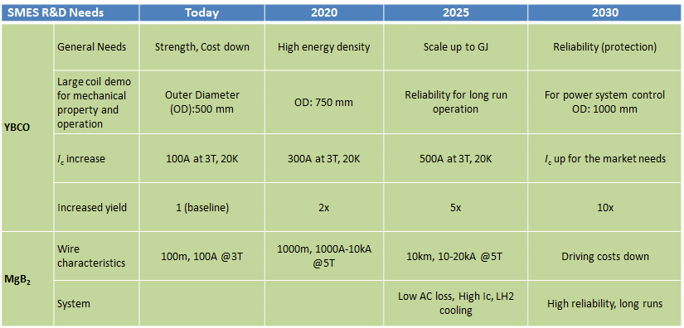

Based on comments collected from respondents, it was suggested that the next step is a YBCO based SMES device because of its high strength and high *I*c even in a high field. However, it would require a higher power GM cryogenic system of more than 100 MW at 20 K.

## 7.4 Summary

There are very limited SMES projects around the world. There is only one SMES (YBCO) activity in the US. There is still interest in using HTS SMES including MgB2 because at more than 10 MJ it will be compact and competitive with other energy storage systems. In summary:

* Commercialization stage could occur from 2025 to 2035
* Required wire cost should be less than $5/kAm for YBCO
* Cryogenic power for GM should be increased
* LH2 cooling will be attractive for MgB2-based devices and may compliment in the future fuel cell vehicle infrastructure.

However, R&D of YBCO coils is relatively new and so far large YBCO and MgB2 coils have not been demonstrated. Projects are needed to follow-up on the U.S. and Japanese past projects to verify the viability of SMES from a technical as well as economical point of view.

For R&D, cost reduction of wire and refrigerator, higher *I*c, reliability and long-run operation system, scale up of the test coil are needed.

# Transformers

Transformers are critical devices deployed across the transmission and distribution system. Electricity may pass through more than five transformers before reaching the end user. Transformers are certainly not new technologies as they have been on the grid for a century. The technology is very mature and there generally is a broad set of manufacturers across the world that product them.

**Benefits of HTS Transformers**

* One-half the size and weight of conventional transformers allowing them to be sited in places that are space constrained and improving transport to final destination
* Use liquid nitrogen instead of oil for the coolant, which eliminates a fire hazard and enables more transformers that can be located in one place

There are a number of old transformers in Japan, US, and EU, that have been experienced 40 years of operation or more which will need to be replaced. In the United States, 70% of large power transformers are twenty-five years or older.[94] This presents an opportunity for replacing these legacy devices with new HTS based ones.



Figure 8.1 Typical example of HTS transformer system.*Courtesy of NEDO.*

Key characteristics of transformers include efficiency, reliability, safety, and size of which superconducting transformers could provide technical advantages over conventional devices. This presents an opportunity for R&D to develop superconducting transformers to improve these characteristics.

## 8.1 Current Status

Most of the R&D on HTS transformers was performed in Japan with the MPACC project.[95] The United States also started a HTS transformer project with a current limiting function.[96]



Figure 8.2 YBCO 2MVA transformer windings.*Courtesy of NEDO.*

Figure 8.1 shows a typical HTS transformer system, consisting of HTS transformer (indicated in green) and cryogenic system. This transformer is a 2 MVA YBCO device developed in the MPACC project.Also in this project, a 20 MVA device was designed. The *I*c of YBCO wire was about 200 A/cm, the best long sample at that time (7 to 8 years ago) and the total length used was 10 km for the 2 MW device. The 20MW device was calculated to require 20km of wire. Figures 8.2 and 8.3 are the YBCO windings for 3 phases of a 2 MVA transformer and the entire view of the experiment, respectively.[97]

In the US, an HTS transformer project was intended to be a 28 MVA three-phase medium-power utility transformer (69 kV/12.47 kV class), featuring SFCL functionality. However, the project plans have changed since one of the key project partners was not able to continue. The project will not result in a full transformer, but it will instead build and demonstrate critical components of a superconducting FCL transformer winding and test for AC loss data and SFCL functionality.



Figure 8.3 Entire view of the YBCO 2MVA transformer experiment. *Courtesy of NEDO.*

In May 2015, Wellington University announced the successful testing of a new HTS transformer.[98] With funding from the New Zealand Ministry of Business, the research team including private companies and utility has successfully conducted a factory test of the new HTS low loss transformer. The transformer was able to transport a high current of 1390 A and the losses were half of that of a conventional transformer. This performance can be attributed to the use of low AC-loss Roebel cable developed by GCS Ltd. in New Zealand. This probably is the first time that a Roebel conductor has been used in a large device.

## 8.2 Transformer Targets

There were not many replies for the commercialization milestones or targets for transformers. Some experts alluded to the merits of the HTS transformer such as high efficiency, compactness, and improved safety because there is no oil coolant. Therefore, it is difficult to predict system-level milestones.

Among them, the addition of SFCL functionality is promising and is also being applied in a HTS cable project to solve the reliability needs of power grid in urban areas.

## 8.3 R&D Issues

R&D needs for HTS transformers include:

* HTS wire AC loss reduction by the multifilamentarization (more than 10 filaments) and twisting/ transposition; Roebel configurations
* Low cost: wire, cooling system, winding fabrication
* Long life and high reliability devices
* Compactness (especially if installed in a urban substation)
* Higher efficiency (reducing cryogenic loss)
* Verification test in a real utility conditions
* Built-in current limiter functionality

## 8.4 Summary

HTS transformers are at the earliest stage of development comparted to other devices for the electric power system. Similar to other power applications, low cost and low AC loss devices are important. Multifilamentarization and Roebel configuration of YBCO wire was found to be very effective to lower the AC loss in previous projects and should be considered also in the future systems. Furthermore, transformers with fault current limiting capability would be of benefit and should be explored further.

# Other applications

This roadmap focuses on the framework of IEA and thus power applications. However, there are also many other notable HTS applications outside of electric power such as High-field Magnet, Magnetic Resonance Imaging (MRI), Nuclear Magnetic Resonance (NMR), Magnetically Levitated trains, and ship degaussing systems. These activities demonstrate that HTS technology can be applied in a variety of applications in many sectors of the world economy. Successful application of HTS wire in these markets can help promote the entire industry.

**High-field Magnets**: The United States is especially active in YBCO high-field magnets, generating over 20 to 30 Tesla which cannot be achieved by conventional superconductors. The National High Magnetic Field Lab (NHMFL)[99] is actively developing an all-superconducting 32 T user magnet project. In Japan, Tohoku University and Toshiba are developing refrigerator cooled high-field (25 T) magnets using YBCO wire.[100]

**MRI**: MRI machines (0.5 T) made with MgB2 wire have been commercialized[101] because MgB2 has the benefit of relatively low cost with long length wire configurations. However, these machines (0.5 T) are in low field compared to the conventional NbTi MRI (3 T). There is ongoing R&D for MRIs using Bi2223 wire and YBCO wire. For instance, a 3 T MRI was developed using Bi2223 wire and a highly stable power supply, successfully taking an MRI image.[102] METI (Japan) is developing a YBCO based magnet. Toshiba and Mitsubishi are studying the YBCO wire magnet technology for MRI.[103]

**NMR**: Bi2223 wire was used also for a high field NMR system. The National Institute for Materials Science achieved 23.5 T (1020 MHz) in an NMR.[104] Many researchers are now considering YBCO wire for higher field NMR machines: MIT, RIKEN and are studying YBCO wire magnets for NMR.[105]

**Accelerators for medical use**: JST (Japan) is developing a YBCO magnet for medical treatment (heavy ion irradiation for cure cancer). This high field and compact magnet downsizes the whole system using a beam accelerator.[106]

**Mag Lev trains**: Recently JR Railway Technical Research Institute (Japan) is developing YBCO magnets with quasi- persistent mode aiming for the future Mag Lev train application. They achieved a 5T generation with a medium sized magnet and held the constant magnetic field for a relatively long time.[107]

**Ship Degaussing systems**: AMSC is pursuing a new application for degaussing systems in Navy ships.[108] Using superconducting wire instead of copper cables can reduce the weight of the ship.

# Summary

HTS has made significant technical progress in a relatively short period of time since its discovery in 1986. Wire and electric grid application development have progressed along the technology commercialization pathway and there are large demonstration projects for several applications. However, several challenges remain so that the technology can realize market maturity.

* **Outreach.** Utilities and the regulatory community are generally unaware of HTS applications and their benefits; communications and outreach should continue to teach them about system benefits; furthermore, regulatory structures could be modified to better incentivize R&D in innovative technologies like HTS.
* **Economics.** The cost associated with manufacturing HTS wire due to sophisticated processes, low yields and limited throughput of the manufacturing processes makes it several times more expensive than copper wire. However, it is not reasonable to simplycompare the cost of an HTS based device to a conventional one. Because of the unique attributes of HTS devices, a *system* cost analysis should be conducted.
* **Process control**. There is a general lack of manufacturing knowledge in producing HTS wires with nanometer-sized precipitates or phases uniformly distributed over kilometer lengths. Additional R&D to improve wire capacity and performance, thus lowering costs, will help to increase competitiveness compared to conventional technologies.
* **Long term reliability.** End users are generally unfamiliar with the materials used in HTS devices and cryogenic systems. Data are not available that proves undiminished product-performance HTS components life time over 30 to 40 years.
* **Business risk.** Uncertainty for total cost of ownership and cost and availability of parts from suppliers in a relatively nascent market.

Additional information on R&D needs for wire, cryogenics, and HTS applications is shown below.

Wire: More than 15 companies are working actively to increase the total production capacity. Some companies manufacturing Bi2223, YBCO and MgB2 can now produce up to 1000 km/year. Cost is recognized as a key factor for device commercialization; the present cost around a few hundred $/kAm (using *I*c at 77 K and self-field) for YBCO should be reduced to around $10/kAm in 2030, the stage of market maturity. Wire companies are conducting R&D to increase *I*c, which will result in lower $/kAm.

Cryogenic system: Responses received from respondents were mostly centered around Turbo-Brayton systems. These systems could reach the mass production stage in 2025 and the market maturity stage in 2030. R&D needs include, enhancement of COP, longer life time and lower cost. Other cryogenic systems are being developed and include: 1) LN2 tank and circulation system in Ampacity project and 2) Stirling refrigerator. LN2 tanks are considered to be cost effective because they do not use any refrigerators. Stirling systems are being developed for high power and reliable system using closed cooling system with compact cryogenics.

Cables: When combining the operating experience of all the cables in the world, there is more than 20 years of operating hours.[109] HTS cable projects have been energized in large scale grid demonstrations around the world. Nearly ten cable demonstration project are ongoing and are classified into distribution voltage; around 10 kV—66 kV and transmission voltage; around 66 kV—275 kV. Survey respondents expect the market maturity stage in 2025 to 2030 with a wire cost of 5 to 25 $/kAm. For cables to reach this stage, R&D must be done to 1) reduce the cost of wire, cryogenics system and cable fabrication, 2) improve system reliability and 3) reduce losses. While R&D will help cables penetrate the market, there is a need to inform end users, like utilities about the benefits of these advanced systems. Utility system planners and operators are generally unaware of how these systems operate and what their benefits are.

Superconducting Fault Current Limiters (SFCL): Resistive type SFCLs have been successfully demonstrated and several projects are currently energized in electric grids across the world. For example, 10 to 20 kV SFCLs have been tested in actual power grids more than one year. Based on the data collected, market maturity could occur in 2025 (of all the applications, the market maturity of SFCLs is the earliest). One of the reasons for this is that SFCLs require proportionally less wire than other HTS applications—several kilometers at most for a distribution level device. Furthermore, the AC losses of the wire are low in the present SFCLs. This results in SFCLs being considered as one of the most promising applications for commercialization.

Generators: Projects are being conceived using YBCO and MgB2 for large off-shore wind turbine generators over 10 MW. At present, they are not in the demonstration stage, but instead basic studies for coils, cryogenics and simulations are being conducted. Based on the data collected, the expectation for the market maturity stage is in 2030. In this stage, a wire cost of 5 to 50 $/kAm is needed, depending on the type of generator.

SMES: While a NbTi-based SMES system is operating at a liquid crystal factory and another site in Japan, an HTS-SMES system has not yet been developed. HTS coils for SMES have been developed using YBCO wire in US, Japan and Korea. Respondents expect the market maturity stage in 2025 to 2035 for 10 to 20 MJ SMES for voltage-drop compensation. However, the wire cost needs to be lower than $5/kAm. For R&D, a large coil fabrication should be tested at a high-field to verify its tolerance for a high hoop stress in SMES. MgB2-SMES using LH2 cooling is also proposed due to the low cost of the wire.

Transformers: There is very little work ongoing with superconducting transformers and there was not much data available on current and future status. However, of all the HTS based devices it appears that transformers would lag other technologies in commercial development. R&D is needed to reduce cryogenic loses and AC losses in the wire.

Figure 10.1 shows a summary of where respondents felt the market maturity and mass production stages would be for the electric power devices. They are indicated by years on the vertical axis of the figure. The closer to the center, the sooner market adoption will be realized. For instance, cables and SFCLs are expected to reach these market stages earlier than others. The market maturity stage for generators and SMES is later than cables and SFCLs. Transformers will take more time to reach widespread commercialization due to technical difficulties and competition with conventional devices. Therefore, the dotted lines in the figure indicate the uncertainty. It is important to note that HTS wire alone will not see market penetration; rather it is a critical enabler for all these applications and those outside the electric power industry. Therefore, it is not represented in the figure below.

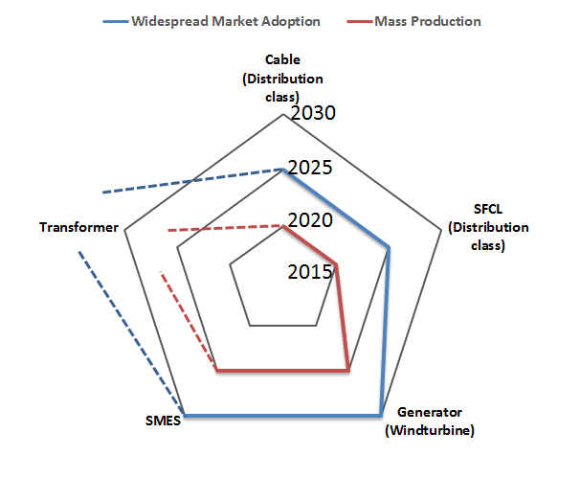

Figure 10.1 Summary of perspectives for the commercialization period.

## TRL (Technology Readiness Level)

Figure 10.2 shows the Technology Readiness Levels (TRLs) based on the data collected from the roadmap effort. The text below contains information about the relative TRL for the applications.

**SFCL: Level 6-8.** SFCL are being demonstrated in the grid. Some companies (Nexans and Applied Materials) are deploying several SFCL devices. These devices are not only in the EU and US, but also in an emerging area such as Thailand.[110]

**Cable: Level 6-7.** HTS cables are also being demonstrated worldwide through national or regional projects, but with government subsidies. These projects are aiming to show long term reliability and ability to solve real world grid problems.

**Generator: Level 3.5-6.** Using Bi2223 wire, a large motor (technologically similar to generator) over 30MW was demonstrated in the US and a few megawatt machines have been tested elsewhere. At present, the field coil of YBCO or MgB2 wires and the cooling system (core technologies) are being studied for the wind turbine generator, while the design study for the whole system has been well studied in many institutes.

**SMES: Level 3.5-5.5.** An LTS SMES device is working in a real factory for voltage drop compensation and was also tested in the grid. For HTS, now large YBCO coils (core device of SMES) are being studied for higher field (that is compact SMES) and low cost system.

**Transformer: Level 3-4.** A few transformers components have been fabricated using YBCO wires. The cost issue, however, is the most considerable obstacle, compared to the conventional reliable and inexpensive transformer, to proceed to the next level.

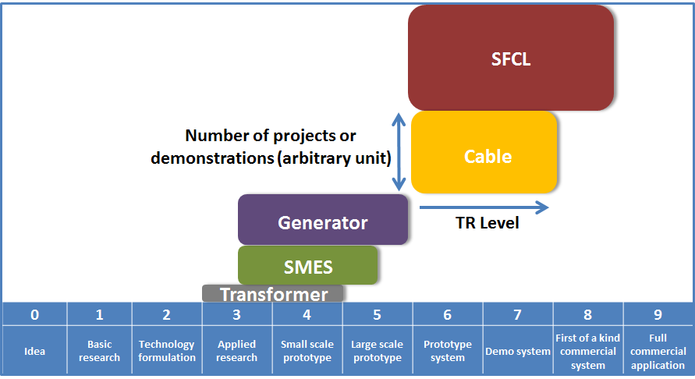

**Figure 10.2 TRL graph for HTS power application as of 2015.**

**Table 10.1 Definition of TRL levels.**

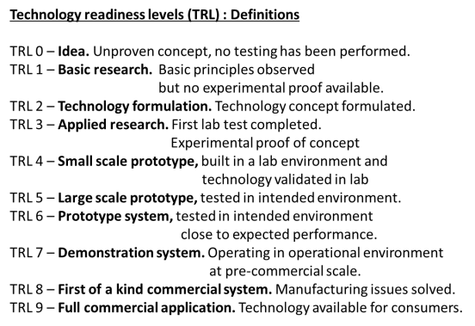

# Appendix A. List of Stakeholders that Contributed to the Roadmap

| **Name** | | | **Organization** | **Country** |
| --- | --- | --- | --- | --- |
| Syed | Ahmed | Southern California Edison | | USA |
| Shirabe | Akita | CRIEPI (Central Research Institute of Electric Industry) | | Japan |
| Naoyuki | Amemiya | Kyoto University | | Japan |
| Katuhiko | Asano | Hitachi, Ltd. | | Japan |
| Michael | Backer | d-Nano | | Germany |
| Xiao-Yuan | Chen | Sichuan Normal University | | China |
| Noriko | Chikumoto | Chubu University | | Japan |
| John | Dackow | SuperPower | | USA |
| Kunihiko | Egawa | JEMA The Japan Electrical Manufacturers' Association | | Japan |
| Keiji | Enpuku | Kyushu University | | Japan |
| Toshihide | Fujii | The Federation of Electric Power Companies of Japan | | Japan |
| Toru | Fukushima | Furukawa Electric Co., Ltd. | | Japan |
| Takataro | Hamajima | Tohoku University | | Japan |
| Yeom | Hankil | KIMM (Korea Institute of machinery & materials) | | Korea |
| Naoki | Hayakawa | Nagoya University | | Japan |
| Hidemi | Hayashi | Kuhen Co., Inc. | | Japan |
| Kazuhiko | Hayashi | SEI (Sumitomo Electric Industries, LTD.) | | Japan |
| Hirokazu | Hirai | Taiyo Nippon Sanso Corporation | | Japan |
| Naoki | Hirano | CEPCO (Chubu Electric Power Co., Inc.) | | Japan |
| Shouich | Honjo | TEPCO (Tokyo Electric Power Company) | | Japan |
| Sidole | Hwang | KEPCO (Korea Electric Power Corporation) | | Korea |
| Yasuhiro | Iijima | Fujikura Ltd. | | Japan |
| Shigeru | Ioka | Toshiba Corporation | | Japan |
| Atsushi | Ishiyama | Waseda University | | Japan |
| Shigeki | Isojima | SEI (Sumitomo Electric Industries, LTD.) | | Japan |
| Junji | Ito | SEI (Sumitomo Electric Industries, LTD.) | | Japan |
| Masataka | Iwakuma | Kyushu University | | Japan |
| Kazuhiro | Kajikawa | Kyushu University | | Japan |
| Yasuharu | Kamioka | ColdTech Associates | | Japan |
| Haran | Karmaker | TECO Westinghouse | | USA |
| Saito | Kazuyoshi | KOBE STEEL, LTD. (JASTEC (Japan Superconductor Technology, Inc.)) | | Japan |
| Takanobu | Kiss | Kyushu University | | Japan |
| David | Knoll | Southwire | | USA |
| Hiroaki | Kumakura | National Institute for Materials Science | | Japan |
| Tsutomu | Kurusu | Toshiba Corporation | | Japan |
| Minoru | Kuwata | NISSIN ELECTRIC Co.,Ltd. | | Japan |
| John | Love | New York State Energy Research & Development Authority | | USA |
| Osamu | Maruyama | TEPCO (Tokyo Electric Power Company) | | Japan |
| Teruo | Matsushita | Kyushu Institute of Technology | | Japan |
| Peter | McIntyre | Accelerator Technology Corp | | USA |
| Yukio | Mikami | Sumitomo Heavy Industries, Ltd. | | Japan |
| Tomoo | Mimura | TEPCO (Tokyo Electric Power Company) | | Japan |
| Antonio | Morandi | Universita Di Bologna | | Italy |
| Shinichi | Mukoyama | Furukawa Electric Co., Ltd. | | Japan |
| Tatsuoki | Nagaishi | SEI (Sumitomo Electric Industries, LTD.) | | Japan |
| Shigeo | Nagaya | CEPCO (Chubu Electric Power Co., Inc.) | | Japan |
| Taketsune | Nakamura | Kyoto University | | Japan |
| Naoko | Nakamura | Mayekawa MFG. CO., LTD. | | Japan |
| Scott | Nickerson | Applied Materials | | USA |
| Kouji | Noguchi | NISSIN ELECTRIC Co.,Ltd. | | Japan |
| Toshio | Nouhara | The Federation of Electric Power Companies of Japan | | Japan |
| Hiroyuki | Ohsaki | Tokyo University | | Japan |
| Seung-ki, | Park | LS Cable & System Ltd. | | Korea |
| Werner | Prusseit | THEVA | | Germany |
| Ming | Qiu | Institute of Electrical Engineering Chinese Academy of Sciences | | China |
| V.R. | Ramanan | ABB | | USA |
| Gordon | Reid | Qdrive | | USA |
| Michael | Ross | AMSC | | USA |
| Sergey | Samoilenkov | SuperOx | | Russia |
| Shinji | Sato | Mitsubishi Electric Corporation | | Japan |
| Ken-ichi | Sato | Teion Kougaku (Cryogenics and Superconductivity Society of Japan) | | Japan |
| Venkat | Selvamanickam | University of Houston | | USA |
| Yukio | Shinoda | The Federation of Electric Power Companies of Japan | | Japan |
| Dietmar | Steinbach | Nexans | | Germany |
| Mischa | Steurer | Florida State University-CAPS | | USA |
| Yukio | Suguro | Yokohama National University | | Japan |
| Kenji | Tasaki | Toshiba Corporation | | Japan |
| Fuminori | Tateo | Fujikura Ltd. | | Japan |
| Pascal | Tixador | Grenoble INP | | France |
| Michael | Tomsic | HyperTech | | USA |
| Makoto | Tsuda | Tohoku University | | Japan |
| Vitaly | Vysotsky | Russian Scientific R&D Cable Institute | | Russia |
| Yinshun | Wang | North China Electric Power University | | China |
| Tomonori | Watanabe | CEPCO (Chubu Electric Power Co., Inc.) | | Japan |
| Jason | Wells | STI | | USA |
| Dag | Willen | nkt Cables | | Denmark |
| Ying | Xin | Tianjin University | | China |
| Hiroharu | Yaguchi | Mayekawa MFG. CO., LTD. | | Japan |
| Sakutarou | Yamaguchi | Chubu University | | Japan |
| Keiichi | Yamamoto | Maekawa MFG. CO., LTD. | | Japan |
| Shunji | Yamamoto | Mitsubishi Electric Corporation | | Japan |
| Hirofumi | Yamasaki | AIST (Advanced Industrial Science and Technology) | | Japan |
| Etsuya | Yanase | Kawasaki Heavy Industries, Ltd. | | Japan |
| Shoichi | Yokoyama | Mitsubishi Electric Corporation | | Japan |
| Yutaka | Yoshida | Nagoya University | | Japan |
| Shigeru | Yoshida | Taiyo Nippon Sanso Corporation | | Japan |

# Appendix B. References

1. IEA “World Energy Outlook 2014”. http://www.worldenergyoutlook.org/publications/weo-2014/
2. Global Environment Fund and Center for Smart Energy. “The Emerging Smart Grid: Investment and Entrepreneurial Potential in the Electric Power Grid of the Future.” October 2005. Available at: http://assets.fiercemarkets.net/public/smartgridnews/sgnr_2007_0801.pdf
3. Analysis from IEA HTS IA when combining the operating experience of all the major cable projects worldwide
4. IEA “World Energy Outlook 2014”. <http://www.worldenergyoutlook.org/publications/weo-2014/>
5. “Cumulative global power sector investment by type and selected region in the New Policies Scenario, 2014-2035” from IEA, “World Energy Investment Outlook – Special Report”, OECD/IEA, 2014. <https://www.iea.org/publications/freepublications/publication/WEIO2014.pdf>
6. Edison Electric Institute. “Transforming America’s Power Industry: The Investment Challenge 2010-2030.” November 2008. <http://www.eei.org/ourissues/finance/Documents/Transforming_Americas_Power_Industry_Exec_Summary.pdf>.
7. Hyper Tech market research, 2014
8. Conectus estimate for global market of superconductivity, www.conectus.org
9. ISIS Technology Scorecard Compendium. Relative Positions of Technologies and Improvement Needs, 2013-2014
10. IEA. “Energy Technology Roadmaps: a guide to development and implementation”,  OECD/IEA, 2014. <http://www.iea.org/publications/freepublications/publication/TechnologyRoadmapAguidetodevelopmentandimplementation.pdf>
11. <http://www.suptech.com/about_superconducting_wire_n.php>
12. Chapter 10 Medical Applications and chapter 12 Large Scale Applications in “100 years of Superconductivity”, edited by H. Rogalla and P. H. Kes, CRC Press, 2012.
13. Chapter 11, Wire and Tapes in “100 years of Superconductivity”, edited by H. Rogalla and P. H. Kes, CRC Press, 2012.
14. 2008 ISTEC report “Market possibility of HTSC power electric devices” by HTSC power device committee.
15. A.B. Abrahamsen, et al., “Superconducting wind turbine generators,”Supercond. Sci. Technol. 23 (2010) 034019
16. <http://www.suptech.com/the_conductus_process_n.php>
17. <http://www.fujikura.co.jp/products/new/superconductor/nd1003.html>
18. <http://www.superpower-inc.com/content/2g-hts-wire>
19. <http://www.sei.co.jp/super/hts/type_h.html>
20. <http://www.amsc.com/library/BRSAMP8700_DS_A4_0514_WEB.pdf>
21. <http://www.superpower-inc.com/system/files/SP_2G+Wire+Spec+Sheet_2014_web_v1.pdf>
22. R. Flukiger, presentation at Jeju Meeting of IEA IA HTS 2014 Dec., <http://www.columbussuperconductors.com/company.asp>. <http://www.hypertechresearch.com/>
23. S. Ye et al, Sci. Technol. 27[5] (2014), p055017.
24. *In this document, “price” and “cost” are used. Price is the amount a customer pays for a product, such as HTS wire. The difference between the price that is paid and the cost that is incurred is the profit the business makes when the item sells. Price is used in wire section of the document because the wire is being sold by companies and “cost” is used only if it is clear as a cost of the wire such as materials cost like Ag or Hastelloy. Cost is used in the application sections of this document because they are not yet being sold commercially and the respondents to the questionnaire considered all elements as a cost.* 
25. Superpower DW Hazelton EUCAS 2013 presentation, Genoa, Italy, 2013 Sept.
26. http://www.superpower-inc.com/content/superpower-adds-thinner-substrate-options-superconducting-wire-offerings
27. T. Izumi et al., presentation at ISS2014, Funabori, Japan, Nov. 2014.
28. V. Selvamanickam, presentation at CCA2014, Jeju, Korea, Dec. 2014.
29. Cryogenics Volume 44, Issue 3, March 2004, Pages 187–195.
30. TEION KOGAKU (Journal of the Cryogenic Society of Japan) 06/2008; 43(6):252-259. DOI: 10.2221/jcsj.43.252.
31. K. Hayashi, “Expectation from the wire company”, presentation at Riken Symposium, Tokyo, April, 2015.
32. T. Izumi et al., presentation at ISS2014, Funabori, Japan, Nov. 2014.
33. V. Selvamanickam, presentation at CCA2014, Jeju, Korea, Dec. 2014.
34. T. Machi et al., Supercond. Sci. Technol. 26 (2013), 105016.
35. A. Frank et al., IEEE/CSC & ESAS EUROPEAN SUPERCONDUCTIVITY NEWS FORUM, No. 3, January 2008.
36. R. Flukiger, presentation at Jeju Meeting of IEA IA HTS 2014 Dec., <http://www.columbussuperconductors.com/company.asp>. <http://www.hypertechresearch.com/>
37. <http://www.uh.edu/news-events/stories/2015/May/0508SuperconductorManufacturing>
38. Y. Kamioka, Teion Kogaku (J. Cryo. Super. Soc. Japan), 49 (2014), p287.
39. Report No.1290 of The Institute of Electrical Engineers of Japan for “Superconducting Devices and System: its present performance and R&D” (2012)
40. Y. Kamioka, Teion Kogaku (J. Cryo. Super. Soc. Japan), 49 (2014), p287.
41. Report No.1290 of The Institute of Electrical Engineers of Japan for “Superconducting Devices and System: its present performance and R&D” (2012)
42. <http://www.htspeerreview.com/pdfs/presentations/day%203/applications/9_AP_LIPA_2_Cable_Project.pdf>
43. S. Ozaki et al., Taiyo Nippon Sanso Technical Report (2014), p.1. <https://www.tn-sanso.co.jp/jp/_documents/news_40609509.pdf>),
44. S. Komatsu et al., TeionKogaku 2014 Spring Domestic Conference Proceedings, p95. N. Nakamura et al., Teion Kogaku (J. Cryo. Super. Soc. Japan), 48(2013), p382.
45. J. Yuan et al., “Status and Progress of a Fault Current Limiting HTS Cable”, Tenth EPRI Superconductivity Conference, October 11-13, 2011,Tallahassee, FL
46. B. Holzapfel, “Short Status Report on AmpaCity project and ZIEHL workshop”, presentation at meeting of HTS-IA, Milano, June, 2014http://www.nexans.com/eservice/Corporate-en/navigatepub_142482_-33667/World_premiere_in_Essen_RWE_integrates_superconduc.html
47. Analysis from IEA HTS IA when combining the operating experience of all the major cable projects worldwide
48. <http://www.nexans.com/eservice/Corporate-en/navigatepub_0_-31642/RWE_Deutschland_Nexans_and_KIT_launch_AmpaCity_pro.html>
49. <http://global-sei.com/sn/2012/423/3a.html>
50. http://passthrough.fwnotify.net/download/610729/http://www.pesicc.org/iccwebsite/subcommittees/subcom_c/C22/Presentations/2012Spring/C-15.pdf
51. D. Lindsay et al., “Operating Experience of 13.2kV Superconducting Cable System at AEP Bixby Station”, B1-107, CIGRE 2008
52. http://www.superpower-inc.com/content/superpower-successfully-concludes-albany-hts-cable-project-demonstrating-world%E2%80%99s-first-integ
53. J. Maguire et al., “Demonstration of a Pre-commercial Long-Length HTS Cable System Operating in the Power Transmission Network”, DOE Peer Review (2009).
54. M. Shimoda et al., Teion Kogaku Proceedings 89th spring meeting, 2014, p96.
55. Private communication with TEPCO
56. http://www.dhs.gov/science-and-technology/st-snapshot-got-power-resilient-electric-grid-feasibility-study-kicks-chicago
57. U.S. Department of Energy Fact Sheet, November 2009, http://energy.gov/sites/prod/files/oeprod/DocumentsandMedia/hts_SFCL_110609.pdf
58. http://www.amsc.com/documents/superconductor-fault-current-limiters-for-mv-ac-networks/
59. L. Martini et al., “Field testing results of the first Italian SFCL project”, presentation at IEA-HTS-IA meeting at Milano, Italy, June, 2014.
60. B. Holzapfel, “Short Status Report on AmpaCity project and ZIEHL workshop”, presentation at meeting of HTS-IA, Milano, June, 2014.
61. S. Hwang, “Current Status of SSFCL Development at KEPCO”, presentation at meeting of HTS-IA, Milano, June, 2014.
62. <http://www.superpower-inc.com/content/technical-documents>: T. Fukushima, et al., "HTS wires for SFCL and FCL transformer"; BIT's 4th New Energy Forum-2014 (NEF2014), September 22, 2014, Qingdao, China; D. Haught, "Recent HTS Activities in the US," IEA HTS Executive Committee Meeting, June 19, 2014, Milan, Italy.
63. <http://www.siemens.com/innovation/en/home/pictures-of-the-future/energy-and-efficiency/power-transmission-stabilizing-the-grid-with-superconducting-systems.html>, and Superconductor Week Vol. 29, Jan. 21, 2015, P1 and 11.
64. L. Martini et al., “Field testing results of the first Italian SFCL project”, presentation at IEA-HTS-IA meeting at Milano, Italy, June, 2014.
65. 2008 ISTEC report “Market possibility of HTSC power electric devices” by HTSC power device committee.
66. Economy and Efficiency of Superconducting Systems, Mathias Noe, Karlsruher Institut für Technologie, 6-7 March 2012
67. IEEE Std 37.302 - 2015 “Guide for Fault Current Limiter (FCL) Testing FCLs rated above 1000 V AC”, to be published in 2016
68. http://www.windpowermonthly.com/article/1297819/question-week-need-10mw-turbine
69. <http://www.amsc.com/documents/seatitan-10-mw-wind-turbine-data-sheet/>
70. <http://www.suprapower-fp7.eu/docs.php>, “Superconducting light generator for large offshore wind turbines”, S Sanz et al., presentation at EUCAS 2013, September 2013 Genoa, Italy.
71. <http://www.nedo.go.jp/fuusha/doc/doc_hamano.pdf>, accessed May 1st, 2015.
72. A.B. Abrahamsen, et al., “Superconducting wind turbine generators,” Superconductor Science and Technology 23 (2010) 034019
73. <http://www.amsc.com/documents/seatitan-10-mw-wind-turbine-data-sheet/>
74. <http://www.suprapower-fp7.eu/docs.php>, “Superconducting light generator for large offshore wind turbines”, S Sanz et al., presentation at EUCAS 2013, September 2013 Genoa, Italy.
75. http://www.windpowermonthly.com/article/1297819/question-week-need-10mw-turbine
76. <http://www.suprapower-fp7.eu/docs.php>, “Superconducting light generator for large offshore wind turbines”, S Sanz et al., presentation at EUCAS 2013, September 2013 Genoa, Italy.
77. AML press release, <http://amlsuperconductivity.com/new-superconducting-magnet-will-lead-to-next-generation-of-wind-turbine-generators/>
78. M. Furuse et al., AIST Report, <https://unit.aist.go.jp/energy/event/20140305/proc/B2.pdf>
79. Poster Presentation at EUCAS 2015 from Laboratory of Applied Physics, Tokyo University of Marine Science and Technology
80. M. Park, “Design and analysis of a 12 MW superconducting wind power generator”, presentation at CCA2014, Jeju, Korea, Dec. 2014.
81. M. Furuse et al., AIST Report, <https://unit.aist.go.jp/energy/event/20140305/proc/B2.pdf>
82. <http://www.suprapower-fp7.eu/docs.php>, “Superconducting light generator for large offshore wind turbines”, S Sanz et al., presentation at EUCAS 2013, September 2013 Genoa, Italy.
83. Private communications to SuperTech and their presentation.
84. Private communication to T. Arndt of Siemens.
85. <http://www.toshiba.co.jp/nuclearenergy/gijyutsu/smes/smes.htm>
86. N. Hirano et al. Teion-kougaku (J. Cryo. Super. Soc. Japan), 49. (2014), p295.
87. N. Hirano et al. Teion-kougaku (J. Cryo. Super. Soc. Japan), 49. (2014), p295.
88. S. Mukoyama, J. Furukawa R&D Report, 131 (2014), p28.
89. <http://www.sandia.gov/ess/docs/pr_conferences/2014/Thursday/PosterSession8/06_Ramanan_V_Superconducting_‌Magnet_poster.pdf>, accessed May 1st, 2015.
90. <http://energy.gov/sites/prod/files/ESS%202012%20Peer%20Review%20-%20Superconducting%20Magnet%20ESS%20with%20Direct%20Power%20Electronics%20Interface%20-%20V.R.%20Ramanan,%20ABB.pdf>
91. R. Gupta et al., “High Field HTS SMES Coil”, presentation at CCA2014, Jeju, Korea, Dec. 2014.
92. N. Hirano et al. Teion-kougaku (J. Cryo. Super. Soc. Japan), 49. (2014), p295.
93. *Long length YBCO wire is starting to be available and R&D for a few small coils (like Figures 7.3 and 7.5) have been tested. For further SMES development, larger HTS coils (including MgB2) should be fabricated to show their merits of strength and high Jc and also for the reliability over long term operation.*
94. Global Environment Fund and Center for Smart Energy. “The Emerging Smart Grid: Investment and Entrepreneurial Potential in the Electric Power Grid of the Future.” October 2005. Available at: http://assets.fiercemarkets.net/public/smartgridnews/sgnr_2007_0801.pdf.
95. NEDO project report of transformer in MPACC project: <http://passthrough.fw-notify.net/download/188070/http://www.nedo.go.jp/content/100550889.pdf> and <http://passthrough.fw-notify.net/static/496178/downloader.js>
96. <https://www.smartgrid.gov/sites/default/files/pdfs/project_desc/OE0000244_SuperPower_Fact%2520Sheet_3.0%5B1%5D.pdf>
97. NEDO project report of transformer in MPACC project: <http://passthrough.fw-notify.net/download/188070/http://www.nedo.go.jp/content/100550889.pdf> and <http://passthrough.fw-notify.net/static/496178/downloader.js>
98. <http://www.victoria.ac.nz/robinson/about/news>, “Transforming power transmission worldwide”(20 May, 2015) Press Release
99. A. V. Gavrilin, “Observations from the Analyses of Magnetic Field and AC Loss Distributions in the NHMFL 32 T All-Superconducting Magnet HTS Insert”, IEEE Transactions on Applied Superconductivity, Vol. 23, NO. 3, June 2013 4300704
100. K. Watanabe, “Upgrade Design to a Cryogen-Free 20-T Superconducting Outsert for a 47-T Hybrid Magnet”, IEEE TRANSACTIONS ON APPLIED SUPERCONDUCTIVITY, VOL. 23, NO. 3, JUNE 2013 4300304
101. R. Flukiger, presentation at Jeju Meeting of IEA IA HTS 2014 Dec., <http://www.columbussuperconductors.com/company.asp>. <http://www.hypertechresearch.com/>
102. Y. Terao, “Newly Designed 3 T MRI Magnet Wound With Bi-2223 Tape Conductors”, IEEE TRANSACTIONS ON APPLIED SUPERCONDUCTIVITY, VOL. 23, NO. 3, JUNE 2013 4400904
103. Presentations of Toshiba and Mitsubishi, ISS2014, Nov. Funabori, Japan.
104. NIMS, “World’s Highest Magnetic Field* (1,020MHz) NMR developed”, http://www.nims.go.jp/eng/news/press/2015/07/201507010.html
105. J. Bascuñán et al., “A New High-Temperature Superconducting (HTS) 700-MHz Insert Magnet for a 1.3-GHz LTS/HTS NMR Magnet”, IEEE TRANSACTIONS ON APPLIED SUPERCONDUCTIVITY, VOL. 23, NO. 3, JUNE 2013
106. Y. Saka et al., “Preliminary study on the field quality of high T_c superconductor model magnet for FFAG accelerators”, CSSJ conference 2015 Spring, 2p-p12.
107. K. Mizuno et al., “Fabrication of 5 T Magnet Using 2G Wires Directed at Maglev Application”, IEEE TRANSACTIONS ON APPLIED SUPERCONDUCTIVITY, VOL. 23, NO. 3, JUNE 2013 3600104.
108. <http://ir.amsc.com/releases.cfm>
109. Analysis from IEA HTS IA when combining the operating experience of all the major cable projects worldwide
110. <http://www.appliedmaterials.com/company/news/press-releases/2015/04/applied-materials-receives-order-for-two-transmission-class-superconducting-fault-current-limiters>